Dream with Us High School Engineering Design Challenge
https://www.nasa.gov/dream-with-us/

Design Name

Submitted by
Team Name

School/Organization Name

Submission Date

__________________________________________________

[REMOVE: A visual representation of the final design is required on cover page]

Table of Contents
Executive Summary 1
1. Introduction 2
1.1 Future Designs 2
1.2 Team Organization 2
1.3 Acquiring and Engaging Mentors 2
1.4 Impact on STEM 2
2. Design 2
2.1 Engineering Design Process 2
2.2 Project Plan 3
2.3 Subsystems 3
2.4 Lessons Learned 4
2.5 Final Design Drawings 4
3. Mission Discussion 5
3.1 Concept of Operations 5
3.2 Comparison and Impact 5
4. Strategic Communications Plan 6
4.1 Strategic Communications Strategy Template 6
4.2 Products to be Created 6
5. Conclusion 6
6. References 6
7. Writing/Format [Informational section for teams: this section is not a part of the Final Document] 7
7.1 References and Citations 7
7.2 Tone of Writing/Professional Appearance 8
7.3 Figures and Tables 8
7.4 Accessibility Standards 9

List of Figures
Figure 1. Three-view of final aircraft. 4
Figure 2. Description phrase to be used as title and description. [If not original] Reprinted [or adapted] from Title (page number), by Author first initial. Second initial. Surname, year, place of publication: Publisher. Copyright [Year] by the Name. 9

List of Tables
No table of figures entries found.

Executive Summary
[One-page Executive Summary includes brief narrative describing the design solution. Judges will look for a high-level overview of how thoroughly and accurately the problem was solved. This summary should be written as a short comprehensive description of your solution. A person reading this one-page summary will understand your solution without needing specific technical expertise or already knowing the specifics of the problem being solved. An executive summary should not contain any citations. Many examples of executive summaries can be found online if the team needs more guidance. (Note: The Executive Summary may serve as a "tiebreaker" if needed. A special judges committee will use this summary to resolve any judging disputes between teams with close scores.)]

Introduction

1.1 Future Designs
[Description of the need for new aircraft designs that utilize different fuel types, with an emphasis on the industry's research and justification for utilizing liquefied natural gas (LNG). This description should include both the need for new aircraft designs beyond the more traditional "tube and wing" design, along with the need to research and utilize different types of fuels. The description should also include challenges and potential economic impacts of new designs.]

1.2 Team Organization
[Describe the organization of the team. Explain how work was divided among the team members. Describe the skills each member brings to the team and the role(s) they had during the project. Possible skills and roles include, but are not limited to, leadership, project management, science, engineering, mathematics, marketing, and communications.]

1.3 Acquiring and Engaging Mentors
[Describe how the team identified and leveraged mentors early and throughout the challenge process.]

1.4 Impact on STEM
[Discuss how participating in this challenge has influenced your perspectives on STEM and on your potential career paths. Include any impact the challenge has had on STEM interest in your school or organization.]

Design

2.1 Engineering Design Process
[Discuss the engineering design processes used during the challenge. Include conceptual, preliminary, and detailed design phases. Briefly describe how the designs of each subsystem are interrelated. This section discusses the processes while the details about each subsystem are provided in 2.3.]

2.2 Project Plan
[Discuss the process used by the team to develop a timeline to accomplish the challenge. In addition, a Gantt chart or a similar type of project management chart must be provided that details the project timeline with tasks and milestones.]

2.3 Subsystems

2.3.1 External Configuration
[Discuss the design process and final design of the external configuration of the aircraft. Include:
-Design process during conceptual, preliminary, and detailed design phases.
-How the requirements were used to generate ideas, how the designs were narrowed down, and how the final design fulfills the requirements.
-Design process must include drawings of ideas during all design phases (missing drawings will result in loss of one fourth of the points for this section).
-How OpenVSP was used during the design phases to generate aerodynamic data, and how OpenVSP results influenced design choices.
-Influence of stability and control requirements on design choices.
-Influence of aircraft performance on design choices.
-Influence of propulsion system on design choices.
-Influence of other subsystems on design choices.
-Final design must include aircraft lift curve and drag polar (use of OpenVSP required).]

2.3.2 Internal Configuration
[Discuss the design process and final design of the internal configuration of the aircraft. Include:
-Design process during conceptual, preliminary, and detailed design phases.
-How the requirements were used to generate ideas, how the designs were narrowed down, and how the final design fulfills the requirements.
-Design process must include drawings of ideas during all design phases (missing drawings will result in loss of one fourth of the points for this section).
-Structural layout of the aircraft.
-Cargo storage. Final details on weight, volume, and containers.
-LNG fuel storage. Final details on weight, volume, and number of containers.
-Requirements for the pilots.
-Influence of propulsion system on design choices.
-Influence of other subsystems on design choices.
-Complete weight and center of gravity analyses. Location of the center of gravity must be provided numerically (from a datum point) and graphically. The graphical location of the center of gravity may be shown on the 3-view of the design (Section 2.5), but if on the 3-view, it must be referenced and discussed in this section. If it is shown later, indicate it is located in another section.]

2.3.3 Ground/Support Equipment
[Discuss the design process and the final design of the ground/support equipment. Must include at least the equipment necessary for loading/unloading cargo and equipment necessary for fueling. Include:
-Design process during conceptual, preliminary, and detailed design phases.
-How the requirements were used to generate ideas, how the designs were narrowed down, and how the final design fulfills the requirements.
-Effect of human resource on design.
-For fueling, discussion on any safety considerations and any changes necessary at an airport to accommodate LNG.]

2.4 Lessons Learned
[Discuss key lessons that were learned during design. Discuss the integration of all subsystems into a single final design and the overall compromises that had to be made.]

2.5 Final Design Drawings
[Include drawings of the final design (with dimensions) in this section. At a minimum include:
-External 3-view of the aircraft.
-Internal 3-view of the aircraft.]

[Example] The following, Figure 1, depicts the three-view of the final aircraft.

[ADD FIGURE-CENTERED]

Figure 1. Three-view of final aircraft.

Mission Discussion

3.1 Concept of Operations

3.1.1 Preparation
[Detail the preparation for a mission.
-Describe the loading of maximum cargo. Include required equipment and number and placement of the containers.
-Describe the fueling of the aircraft. Include the requirement equipment and safety procedures.
-Include the number of people required for the tasks.
-Estimate the time required to complete the tasks.]

3.1.2 Mission Performance
[Analysis of the mission to demonstrate that the aircraft meets performance requirements. Mission is at maximum cargo. Total fuel usage must be included.
-Takeoff.
-Climb.
-Cruise.
-Reserve mission.
-Approach.
-Landing.]

3.1.3 Post-Mission
[Detail the post-mission.
-Describe the unloading of maximum cargo.]

3.2 Comparison and Impact
[Compare the design and performance of this new LNG cargo aircraft to current cargo aircraft that carry similar payloads. From this comparison, describe the potential economic impact of the new design.]

Strategic Communications Plan

4.1 Strategic Communications Strategy Template

4.1.1 Background and Purpose
[Provide background for the communications strategy (such as a short summary of how and what your team plans to present to the freight company). Briefly explain why a presentation strategy is important in this situation. What challenges, beyond the technical challenges themselves, can make it difficult to get support for your project? Your team can assume that the people within your company that you are presenting to have some technical knowledge but may not know all of the details about aircraft design or liquefied natural gas (LNG).]

4.1.2 Audience and Messaging
[Include primary and secondary audiences, if applicable. Include an outcome for each audience: why are you connecting with them? What do you want to happen because of their involvement? What are the main points you are trying to make for each audience (these can be bullet points)?]

4.2 Products to be Created
[Show the presentation and any other products that will be created. Note: a presentation alone is fine; any other products are completely optional.]

Conclusion
[Provide a brief conclusion to your Engineering Notebook. Summarize the important aspects of your design. Explain why this design is the best design for this challenge (make sure to base your argument on the analysis and justification you provided in your Engineering Notebook). Be sure to justify all the design choices that you made.]

References
This is where the details of any reference citations are maintained. Do not include a reference citation in the References section if it has not been directly cited in the body of this document. Use the current APA style for references and citation. References should be ordered alphabetically. If any of the references have the same author and year, place in order by the first word in the title and add an alphabetical identifier to the year (e.g., 2012a) and ensure this year and identifier is used in any in-text citations.

See the following for APA formatting of required references: https://owl.purdue.edu/

Writing/Format [Informational section for teams: this section is not a part of the Final Document]
Neat, orderly and readable, font size no smaller than 11 pt Arial throughout with 1.5 line spacing, except in Executive Summary, Captions, and References (single spaced allowed). Letter size paper (8.5 in. by 11 in.) with 1-in. margins; pages numbered. The Engineering Design Notebook must follow the paragraph order of the Scoring Rubric including paragraph numbering.

The Engineering Notebook submission is limited to 80 pages maximum including all front and back matter (cover page, table of contents, appendices, etc.). Sections past the 80-page limit will receive a score of 0. Points may be deducted in individual sections if content is not in correct location or hard to understand. For each line item, up to 20% of the maximum points for that line may be deducted for grammar. For example, if the line item is worth 10 points, up to 2 points may be deducted for grammar.

7.1 References and Citations
Reference citations are to be used, where appropriate, to support work. Use the following research and reference guidelines in the development of your submission:
- You should have references identifying the merit of your proposed research and supporting any assertions you make. As part of this process, you need to perform a basic literature review and identify supporting material as part of your proposal. Add references and citations to support why your research is worth pursuing. What is the value of performing it? What will it identify that other research has not? Provide some detail regarding any problems or issues that can be used as rationale to support why this is valuable.
- Add a supporting citation to every sentence that is not entirely your own observation or thought, adding quotes when including someone else’s exact words. It is good practice to use supporting citations as it lends credibility to what you are stating. If you do not cite a source and it is not your original thought, it is PLAGIARISM and your team will lose points accordingly.
- All direct quotes need a page, section, or paragraph number reference (e.g., Terwilliger, 2012, p. 4).

7.2 Tone of Writing/Professional Appearance
Avoid an informal or narrative tone. Instead, focus on use of a formal, academic tone.

Use the following grammatical and writing guidelines in the development of your submission:
- Always spell-check
- First time use should define an acronym. For example, “The use of uncrewed aircraft systems (UAS) has served to reduce risk to humans by removing the crew from a hazardous operating environment (U.S. GAO, 2008).” Subsequent uses through the remainder of the document should be, “UAS.”
- Paragraphs should be at least three sentences long
- Spell out numbers less than 10
- Use numerals for numbers over nine
- When referring to a variable, such as population (N), it should be in italics
- Refrain from using contractions (e.g., don’t, can’t, didn’t, etc.)
- Avoid colloquial, superlative, or slang expressions in scientific/academic writing (e.g., on the other hand)
- Refrain from self-referencing (e.g., I, myself, me) in scientific/research writing. If you must refer to yourself, do it in the third person. For example, the researcher will…

7.3 Figures and Tables
Figure and table reference should appear in the following format (always precede the caption and image/table with an in-text reference to explain or depict the connection to the text). For example, “Figure 2 depicts an example for the purposes of explaining figure use, reference, and appearance.”

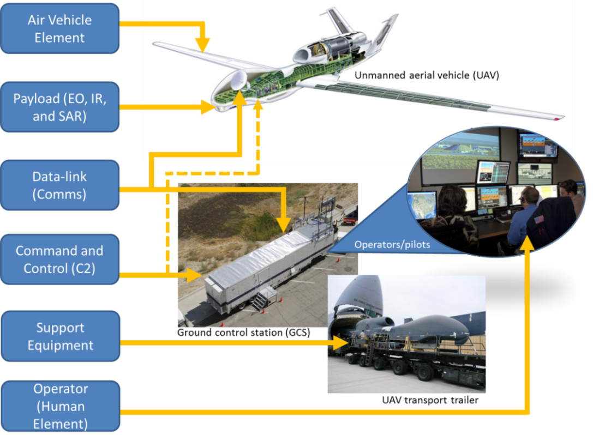
Figure 2. Description phrase to be used as title and description. [If not original] Reprinted [or adapted] from Title (page number), by Author first initial. Second initial. Surname, year, place of publication: Publisher. Copyright [Year] by the Name.

7.4 Accessibility Standards
The submitted Engineering Notebook must meet accessibility standards.
- To make your documents accessible and compliant with Section 508, it’s important to add descriptive alt tags to all images, diagrams, and graphics. Alt tags provide text descriptions that assist screen readers in conveying visual information to users with disabilities. When adding alt tags, use clear and concise language to describe the purpose and content of each image. In Microsoft Word, right-click the image, select “Edit Alt Text,” and enter your description. This simple step ensures everyone can access and understand your content, regardless of their abilities.
- Alt Text Sample on a PC (right click over the image and a drop down will appear, select inspect accessibility properties and it will open the web inspector “View Alt Text” option. If you select that option an “Alt Text” window opens with a grey box and instructions for how to create the alt tag.
- Alt Text Sample on a Mac (right click over the image and a drop down will appear, select inspect accessibility properties and it will open the web inspector. There is a gray area that is highlighted. It is the location of the image alt tag in the code. You may need to click the gray arrow next to the word “image” in order to see the whole alt tag. To hide the properties window click on the X in the top right corner of the window.

