NASA Cost and Schedule Symposium August 25–27

A coffee kiosk will be available offering à la carte coffee, water, snacks, breakfast bars, and pastries for purchase (card only).

Coffee Kiosk Menu Below
Hours: To be determined based on event schedule

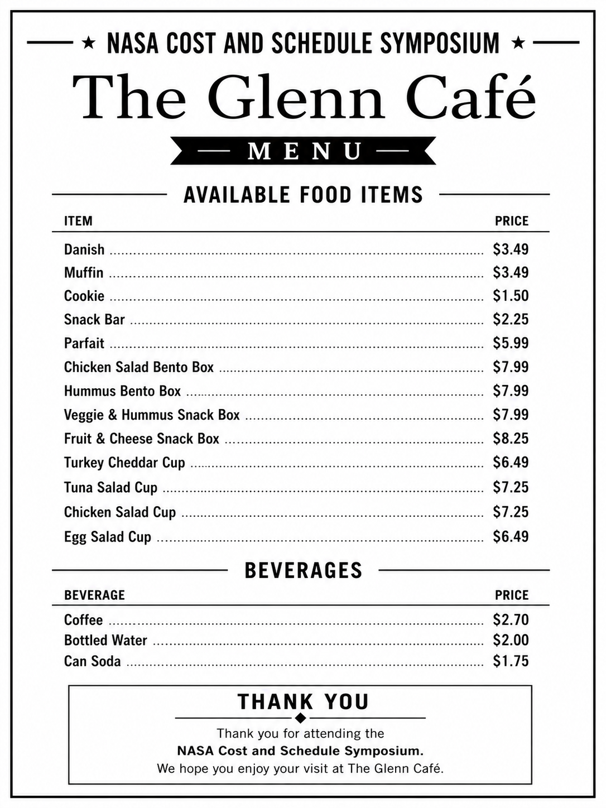

Premium Lunch Box Options
$18.99 per box
Each premium lunch box includes:
- Dill Pickle
- Cookie (Chocolate Chip)
- Deep River Kettle Chips (2 oz.)
- Trail Mix (2 oz.)
- Water Bottle (10 oz.)

Choose One Sandwich:
Turkey on Ciabatta with Garlic Herb Aioli
- Sliced Turkey Breast, Ciabatta Bun, Mayo, Green Leaf Lettuce

Teriyaki Chicken Wrap
- Diced Chicken, Flour Tortilla, Carrots, Bell Peppers, Cucumber, Cabbage, Onion, Teriyaki Glaze

Ham & Cheese on Sourdough
- Ham, Sourdough Bread, Havarti Cheese, Honey Dijon

Fresh Veggie Wrap
- Hummus, Spinach Herb Wrap, Cucumber, Bell Pepper, Carrot, Tomato, Lettuce, Black Beans

Value Boxed Lunch Options
$9.99 per box
Each value boxed lunch includes:
- Fruit
- Chips
- 8 oz Water

Choose One Option:
Turkey & Swiss Wrap
Veggie Wrap
Ham & Cheddar Wrap
Chef Salad

Ordering Instructions
Ordering Window: July 20–August 7 (Orders can be placed any day and any time during this window). All boxed lunches must be ordered by August 7.

We cannot accommodate any special requests/changes to the boxed lunches.
Only add lunch box items to your cart, do not add any other menu items

How to Place Your Order

- Scan the QR Code to open the Glenn Café Online Ordering page
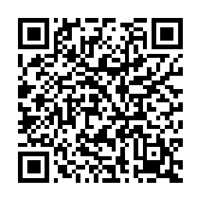

- Click the Timer/Clock icon 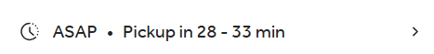
    - Select “Schedule for Later”
    - Select Tues, 8/25 (no need to populate time)
    - Click “Confirm”

- In the three-line icon 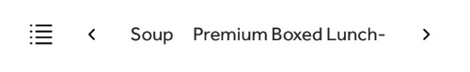
scroll right to the menu section titled, “Cost and Schedule Symposium”

- Click the lunch box option(s) you would like to order by clicking on the item and then in the Special Instructions box add the date you want that selection for, and click “Add to Cart”

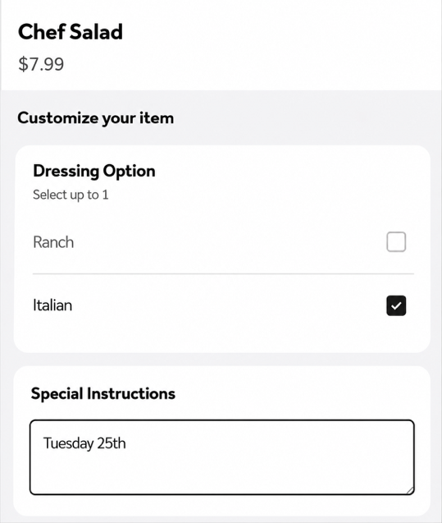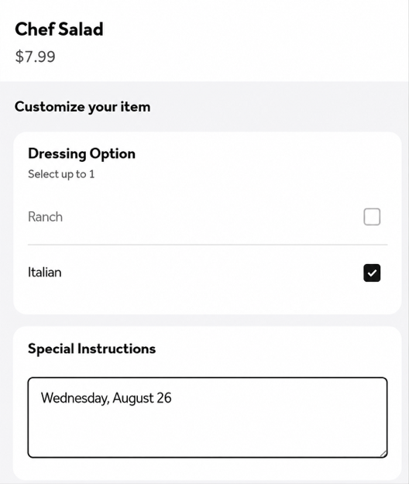

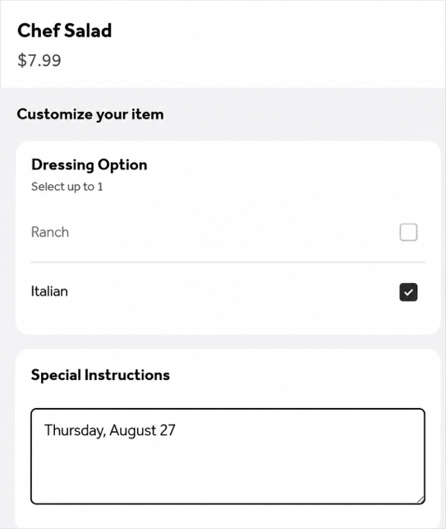

- Repeat Step 4 for each day you would like to order lunch.

- Once your selections are complete, Click View order, confirm your order selection(s) and click Checkout to complete payment. (At Checkout, populate your e-mail address, First and Last names, and phone number; Ignore pickup details section, and continue to the Payment section and finally click Place Order.

If you have any questions or need assistance placing your order, please contact Patrick Chamoun at patrickchamoun@snapgourmetfoods.com

