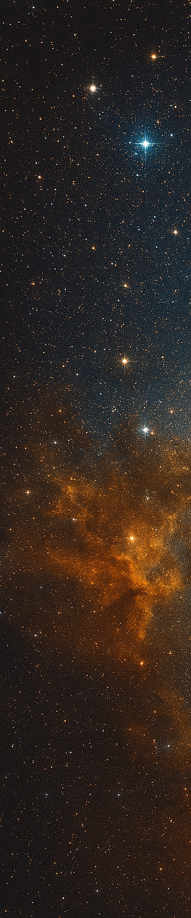
2026 NASA Cost and Schedule Symposium Call for Award Nominations


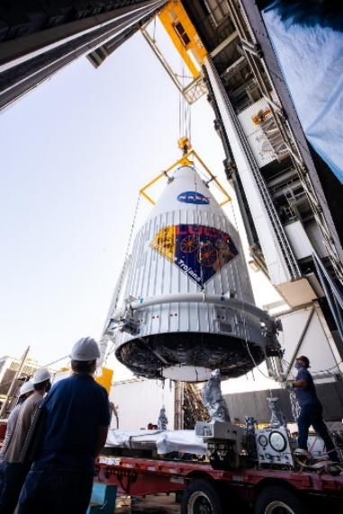
Schedule and Due Dates
July 10: Award Nomination Deadline
Aug 26: Awards Banquet
Award Descriptions & Nomination Submissions
Requirements will be posted on the NCSS website.
Winners will be announced at the Awards Banquet.
Nominations and Winners will be posted on the NCSS website after the Symposium.
Symposium Logistics
August 25th – 27th
Glenn Research Center
Cleveland, Ohio
Registration
Links and Detailed Logistics are forthcoming and will be posted on the NCSS website.
Contact Information
Symposium Email:
hq-ncss@mail.nasa.gov
Awards POC: Justin Hornback
Symposium Website
www.nasa.gov/ocfo/nasa-cost-and-schedule-symposium/

The NASA Cost, Schedule, and EVM Communities invite you to nominate your favorite Analyst!
We are pleased to announce the awards call for our upcoming 2026 NASA Cost and Schedule Symposium (NCSS).

Outstanding work has been done by individuals and estimating/analysis teams across the Agency this past year. Please take a moment to recognize those who have distinguished themselves through their accomplishments, dedication, leadership, and teamwork. Submit an award nomination on their behalf. Don't miss this opportunity to ensure deserving colleagues receive the recognition they've earned.

We are accepting nominations for the following annual award categories:
- The NASA Cost and Schedule Leadership Award
- The NASA Cost and Schedule Analyst of the Year Award
- The NASA Rising Star Award
- The NASA Cost and Schedule Team Award
- The NASA Cost and Schedule Support Contractor of the Year Award
- The NASA Top Community Support Award
- The William S. Rutledge Lifetime Achievement Award

The descriptions for each award are included as a separate attachment in the email that included this flyer. The descriptions will also soon be made available on the NCSS website.

The awards will cover the period of September 1, 2025 – August 31, 2026. Nominations can be submitted by anyone in our NASA estimating and analysis community, but they must be emailed by close of business on July 10, 2026.
Provide Submission to: hq-ncss@mail.nasa.gov
Subject Line: 2026 NCSS Award Nomination
The selection process and criteria for the awards, along with the requirements and format for each award submission will soon be made available on the website. Please follow the instructions for nomination.
Questions: Please email Justin Hornback, hq-ncss@mail.nasa.gov

Award Descriptions

NASA Cost and Schedule Leadership Award
The NASA Cost and Schedule Leadership Award is established to provide recognition to an individual who has brought leadership and inspiration to the space cost, EVM, and/or schedule community in activities such as championing a cause, leading and mentoring others in the space cost, EVM, and/or schedule community, acting as a strong advocate for the NASA programmatic community, and garnering the respect of his/her peers. The nomination is open to current NASA civil servants and JPL/APL personnel in the cost, EVM, and schedule community of practice.

NASA Cost and Schedule Analyst of the Year Award
The NASA Cost and Schedule Analyst of the Year Award is established to provide recognition to an individual who has excelled in the technical merits of cost estimating, EVM analyses, and schedule analyses at a specific Center or at NASA Headquarters. Specific areas may include the following: economic analysis; cost/price analysis; schedule management, earned value management, project evaluation; cost/benefit analysis; quantitative analysis to include the application of statistical techniques to contemporary programs; policy analysis; special studies; the design of systems to integrate and improve management information; cost effectiveness analysis; cost or schedule modeling; cost and schedule forecasting using earned value management data; and/or parametric cost or schedule estimating. The nomination is open to current NASA civil servants and JPL/APL analysts working in the cost and schedule community of practice.

NASA Cost and Schedule Rising Star Award
The NASA Cost and Schedule Rising Star Junior Award is established to provide recognition to a junior (approximately eight years or less experience) individual who has demonstrated talents, achievements, and leadership merits of a future leader in the technical areas of cost estimating and analysis, earned value management, and/or schedule management at a specific Center or at NASA Headquarters. Specific areas may include the following: economic analysis; cost/price analysis; schedule management; project evaluation; cost/benefit analysis; quantitative analysis to include the application of statistical techniques to contemporary programs; policy analysis; special studies; the design of systems to integrate and improve management information; cost effectiveness analysis; cost or schedule modeling; cost and schedule forecasting using EVM data; and/or parametric cost or schedule estimating. The nomination is open to co-ops, current NASA junior civil servants, JPL/APL analysts, and support contractors in the cost, EVM and schedule communities of practice.

NASA Cost and Schedule Team Award
The NASA Cost and Schedule Team Award is established to provide recognition for outstanding team performance in the NASA cost, EVM and/or schedule communities as evidenced by documentation of specific accomplishments during the past year. This award recognizes the efforts of the team whose members have worked together successfully, reaching goals through commitment, motivation, and communication. The success of the team, adoption of study results or resulting savings from the team's efforts will be necessary to determine the effectiveness of the team. Examples of team efforts are NASA cost estimating teams and NASA schedule management teams, special study teams, teams who have advanced NASA’s cost and/or schedule initiatives, or related efforts. A team is defined as a grouping of individuals, made up of four to twenty individuals, brought together temporarily to perform a specific task not in the purview of the current office structure. The team may consist of current NASA civil servants, cross Center teams, and support contractors.

NASA Cost and Schedule Support Contractor of the Year Award
NASA support contractors play an important role in helping NASA achieve our missions and are considered part of the extended NASA family. The NASA Cost and Schedule Support Contractor of the Year Award is established to recognize an individual who has provided outstanding contractor support to the NASA cost, EVM, and/or schedule communities. This support may be Center specific, Headquarters, cross Center support, etc. The Contractor must have worked supporting NASA for a minimum of one calendar year and significantly contributed to the field of Cost Estimating and Analysis, EVM and/or Schedule Management. This nomination is open to an individual support contractor supporting NASA costs, EVM, and/or schedule community efforts.

NASA Top Community Support Award
The NASA Top Community Support Award is established to provide recognition to a NASA Center, NASA HQ, JPL or APL employee, or Support Contractor who has best supported the cost, EVM, and/or schedule communities of practice, internal to NASA, by selflessly undertaking tasks focused on improving the overall analysis and estimation community and all its members. We have several individuals who go the extra mile to support our profession by contributing to either the betterment of the entire community, increasing collaboration amongst our community and other organizations, or by addressing specific common challenges that we all face in meeting the demands of our jobs. The individual should have demonstrated their willingness to put the NASA PP&C community first while never expecting any individual recognition for their efforts. The nomination is open to NASA civil servants and JPL/APL employees, and Support Contractors in the Cost Estimating and Analysis, EVM, and Schedule Management fields.

William S. Rutledge Lifetime Achievement Award
The William S. Rutledge Lifetime Achievement Award is established to recognize an individual who has demonstrated exceptional dedication and made an outstanding contribution to the NASA cost estimating community, EVM and/or the NASA schedule management community during his or her lifetime. This individual is passionate about their work, skilled in the art of cost estimating, and has/had practiced these fundamentals for a significant amount of his or her career. They have demonstrated commitment to the profession over time. The Nominee’s initiative and leadership in the cost estimating, EVM and/or schedule management communities may take the form of hands-on work (in any related area of cost estimating, EVM and/or schedule management); promotion of the awareness of new cost, EVM and schedule policies, models or tools; the development of new cost, EVM and schedule policy(s), improvement(s) to cost, EVM and schedule research and/or models; the development of new cost and schedule models that have enhanced the tools for the cost, EVM and/or schedule communities. This individual overcame obstacles. This person may have strengthened cooperative efforts both within NASA’s cost estimating, EVM and/or schedule management fields as well as with outside Agencies or Departments, and cost estimating, EVM and/or schedule management support contractors. The recipient of the Award has made a lasting difference to the NASA Cost Estimating and Analysis, EVM and/or Schedule Management Communities. This nomination is open to current and retired NASA civil servants and JPL/APL personnel.

