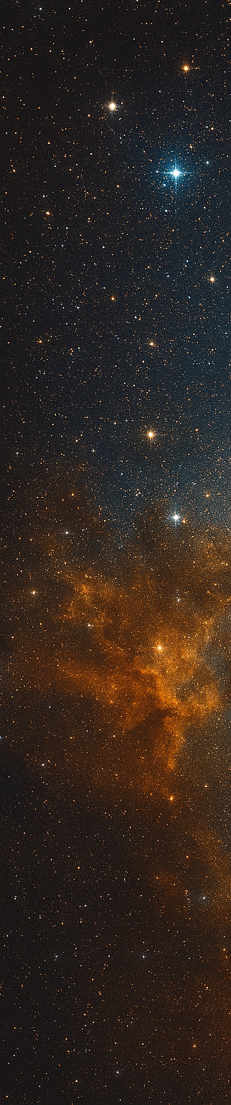



Schedule & Due Dates
June 12: Abstracts Due
June 22: Notification of Acceptance
August 17: Presentations Due
Final Symposium Agenda will be posted on the NCSS website.

Symposium Logisitcs
August 25th – 27th
Glenn Research Center
Cleveland, Ohio
Registration
Links and Detailed Logistics are forthcoming and will be posted on the NCSS website.
Contact Information
Symposium Email:
hq-ncss@mail.nasa.gov
Abstract POC: Mr. Charles Hunt
Please contact utilizing NCSS Email.
Symposium Website
www.nasa.gov/ocfo/ppc-corner/nasa-cost-and-schedule-symposium/
Provide Submissions to: hq-ncss@mail.nasa.gov
- Subject Line: 2026 NCSS Abstract
- Please include:
  - A primary point of contact
  - A list of all authors, including contact info
  - An abstract not to exceed two pages
  - Desired time slot*: 30, 45, or 60 min
*Presentations should be 30 minutes, but please inform us in your email if you would prefer a 45 or 60 minute slot. There are a limited number of 45-60 minutes slots available.
Questions: Please email Mr. Charles Hunt, hq-ncss@mail.nasa.gov
We are seeking presentations covering a wide variety of estimating and analysis topics, including:
- Cost and Schedule Risk Analysis: Techniques, Results, and Lessons Learned
- Effects of Acquisition Approach on Estimating and Analysis
- Affordability and Sustainability Analysis
- NASA Policies on Cost, Schedule, and EVM
- Results of NASA Data Collection and Research
- Independent Cost and Schedule Assessment
- Cost and Schedule Analysis Tools, Methods, and Processes
- Schedule Management
- Earned Value Management
- Joint Cost and Schedule Risk Analysis
The NASA Cost, Schedule, and EVM
Communities invite you
to contribute to our annual
NASA Cost and Schedule Symposium!
2026 NASA Cost and Schedule Symposium
Call for Presentations

