Dream with Us High School Engineering Design Challenge
https://www.nasa.gov/dream-with-us/

Design Name

Submitted by
Team Name
Team Member Names
(List team members, with age, grade, email addresses, and designate team leader – a table is fine to list information)

School/Organization Name
Address

Submission Date
Coach(s)/Advisor(s): Coach Name
Coach Contact Info (Address, Phone, Email)

Coach Validating Signature:
__________________________________________________
[REMOVE: An electronic signature of the coach is expected.]
[REMOVE: A visual representation of the final design is required on cover page]

[REMOVE: While the template is provided for convenience as a Word document, it is highly recommended that the report is submitted as a PDF to ensure proper formatting]
Table of Contents
Executive Summary 1
1. Introduction 2
1.1 Local Agricultural Pest 2
1.2 Team Organization 2
1.3 Acquiring and Engaging Mentors 2
1.4 Impact on STEM 2
2. Design 2
2.1 Engineering Design Process 2
2.2 Project Plan 3
2.3 Subsystems 3
2.4 Lessons Learned 4
2.5 Final Design Drawings 5
3. Mission Discussion 5
3.1 Concept of Operations 5
3.2 Benchmark Mission 6
3.3 Safety Requirements 6
4. Business Case 7
4.1 Cost Analysis 7
4.2 Logistics Details 8
4.3 Economic Impact 8
5. Public Affairs/Communications Plan 8
5.1 Public Relations Strategy Template 8
5.2 Products to be Created 8
5.3 Distribution Plan 8
6. Conclusion 9
7. References 9
8. Writing/Format [Informational section for teams: this section is not a part of the Final Document] 9
8.1 References and Citations 10
8.2 Tone of Writing/Professional Appearance 10
8.3 Figures and Tables 11

List of Figures
Figure 1. Three-view of final uncrewed system design. 5
Figure 2. Description phrase to be used as title and description. [If not original] Reprinted [or adapted] from Title (page number), by Author first initial. Second initial. Surname, year, place of publication: Publisher. Copyright [Year] by the Name. 11

List of Tables
No table of figures entries found.

Executive Summary
[One-page Executive Summary includes brief narrative describing the design solution. Judges will look for a high-level overview of how thoroughly and accurately the problem was solved. This summary should be written as a short comprehensive description of your solution. A person reading this one-page summary will understand your solution without needing specific technical expertise or already knowing the specifics of the problem being solved. An executive summary should not contain any citations. Many examples of executive summaries can be found online if the team needs more guidance. (Note: The Executive Summary may serve as a "tie-breaker" if needed. A special judges committee will use this summary to resolve any judging disputes between teams with close scores.)]

Introduction

1.1 Local Agricultural Pest
[Explain your decision on the local agricultural pest selected for this challenge. Describe the pest and the plant(s) affected. Describe the impact of this pest on the local agricultural industry with an emphasis on the economic impact. Explain what resources were used to determine the pest selection and its impact. Do not assume the reader is familiar with this pest considering it may not be well known outside of your local area.]

1.2 Team Organization
[Describe the organization of the team. Explain how work was divided among the team members. Describe the skills each member brings to the team and the role(s) they had during the project. Possible skills and roles include, but are not limited to, leadership, project management, science, engineering, mathematics, marketing, and communications.]

1.3 Acquiring and Engaging Mentors
[Describe how the team identified and leveraged mentors early and throughout the challenge process.]

1.4 Impact on STEM
[Discuss how participating in this challenge has influenced your perspectives on STEM and on your potential career paths. Include any impact the challenge has had on STEM interest in your school or organization.]

Design

2.1 Engineering Design Process
[Discuss the engineering design processes used during the challenge. Include conceptual, preliminary, and detailed design phases. Briefly describe how the designs of each subsystem are interrelated. This section discusses the processes while the details about each subsystem are provided in 2.3.]

2.2 Project Plan
[Discuss the process used by the team to develop a timeline to accomplish the challenge. In addition, a Gantt chart or a similar type of project management chart must be provided that details the project timeline with tasks and milestones.]

2.3 Subsystems

2.3.1 Air Vehicle
[Discuss the design process and final design of the air vehicle (airframe configuration, power plant [propulsion], flight controls). Include:
-Design process during conceptual, preliminary, and detailed design phases.
-How the requirements were used to generate ideas, how the designs were narrowed down, and how the final design fulfills the requirements.
-Design process must include sketches of ideas during all design phases (missing sketches will result in loss of one fourth of the points for this section).
-Complete weight and center of gravity analyses. Location of the center of gravity must be provided numerically (from a datum point) and graphically. The graphical location of the center of gravity may be shown on the 3-view of the design (Section 2.5), but if on the 3-view, it must be referenced and discussed in this section. If it is shown later, indicate it is located in another section.
-Final design must include description of components including number of components required.
-Clear and concise description on how C3 (see below), payload, and ground/support affected design.]

2.3.2 Command, Control, and Communications (C3)
[Discuss the design process and final design of C3. Discussion of the ground control station must be included in this section. Include:
-Design process during conceptual, preliminary, and detailed design phases.
-How the requirements were used to generate ideas, how the designs were narrowed down, and how the final design fulfills the requirements.
-Effect of human resources (pilot, monitor) on design.
-Final design must include description of components including number required. Include final selection of human resources as well including number and cost.
-Discussion of the ground control station must include sketch(es).
-Description of the equipment/sensors required for detect and avoid must be included in this section. Application of DAA provided in 3.3.1.
-Description of the equipment required for providing real time and accurate location. Application of the equipment provided in 3.3.3.]

2.3.3 Payload – Pest Detection
[Discuss the design process and the final design of the pest detection payload system. Include:
-Design process during conceptual, preliminary, and detailed design phases.
-How the requirements were used to generate ideas, how the designs were narrowed down, and how the final design fulfills the requirements.
-Detailed description of how the sensors detect pests or evidence of pests.
-Final design must include description of components including number required.]

2.3.4 Payload – Sample Gathering
[Discuss the design process and the final design of the sample gathering payload system. Include:
-Design process during conceptual, preliminary, and detailed design phases.
-How the requirements were used to generate ideas, how the designs were narrowed down, and how the final design fulfills the requirements.
-Design process must include sketches of ideas during all design phases (missing sketches will result in loss of one fourth of points for this section).
-Detailed description of how the system gathers a sample and stores the sample on the aircraft.
-Final design must include description of components including number required.]

2.3.5 Ground/Support Equipment
[Discuss the design process and the final design of the ground/support equipment. Include:
-Design process during conceptual, preliminary, and detailed design phases.
-How the requirements were used to generate ideas, how the designs were narrowed down, and how the final design fulfills the requirements.
-Effect of human resource on design.
-Final design must include description of components including cost and number required. Include final selection of human resource as well including number and cost.]

2.4 Lessons Learned
[Discuss key lessons that were learned during design.]

2.5 Final Design Drawings
[Include drawings of the final design (with dimensions) in this section. At a minimum
-3-view of the aircraft.
-Sample gathering system.
-Final ground control station.]

[Example] The following, Figure 1, depicts the three-view of the final unmanned system design.

[ADD FIGURE-CENTERED]

Figure 1. Three-view of final uncrewed system design.

Mission Discussion

3.1 Concept of Operations

3.1.1 Preparation
[Detail the initial preparation prior to a mission.
-Describe the steps to set up the ground control station and any other equipment.
-Describe steps to prepare the aircraft for a mission: location of a staging area, checking correct fuel/charge, checking sensors, programming flight path, completing final safety check of aircraft and environment, movement of aircraft from a staging area to a takeoff area (if needed), etc.
-Describe who performs the different tasks.]

3.1.2 Pest Detection
[Detail how the system detects pests during flight.
-Describe how the sensors detect pests or evidence of pests.
-What communication between the aircraft and the ground station is required during detection?
-What other communication is required between the aircraft and operators?]

3.1.3 Sample Gathering
[Detail how the system gathers a sample.
-Describe how it is determined that a sample should be gathered.
-Describe how the aircraft gathers a sample.
-Describe how the sample is stored on the aircraft and whether multiple samples can be gathered in a single flight.
-What communication between the aircraft and the ground station is required during sampling?
-What other communication is required between the aircraft and operators?]

3.1.4 Post-Mission
[Detail the post-mission.
-Describe steps after the final mission of the day for the system.
-Include storing the aircraft.
-Include storing the ground control station and any other equipment.]

3.2 Benchmark Mission
[Describe how the system completes the benchmark mission. Discuss pre-mission setup and the time it requires. Discuss the number of flights that are required and the length of time of each flight. Discuss the steps necessary at the ground station to prepare the aircraft between flights (e.g., refueling/recharging, removing samples, etc.). Show through analysis that the aircraft has sufficient energy (e.g., battery or fuel) to complete each required flight. Also show that the aircraft has sufficient communication range for all flights. Discuss post-mission steps and the time it requires. Summarize the full benchmark mission including total time, total number of flights, and total flight time.]

3.3 Safety Requirements

3.3.1 Detect and Avoid
[Discuss design and implementation of the Detect and Avoid (DAA) System to ensure aircraft and public safety. Include:
-Reasoning behind the location of decision-making process: onboard or at the ground control station
-Clear discussion of how the DAA fits with the C3 capabilities from 2.3.2
-Clear discussion that the DAA allows the aircraft to sense, detect a conflict, and avoid any cooperative or non-cooperative obstacles. Must provide distances/times for the detection ranges and the decisions and reasons/justification for those selections. Must include the communication required with the DAA such as the communication between aircraft and operators.
-Clear discussion that the DAA capabilities allow for safe flight among plants for detection and sample gathering.]

3.3.2 Lost Link Protocol
[Describe the protocols/procedures when the aircraft experiences a partial loss of communication and a total loss of communication to ensure aircraft and public safety. In both cases, clearly describe what steps the aircraft and operator will perform.]

3.3.3 Integration with Manned Aircraft and Other Aircraft
[Describe the requirements to integrate UAS successfully and safely into flight with crewed and other aircraft in the area.]

3.3.4 Additional Safety
[Explain any additional safety features or procedures for your design. These additional safety features are to account for possible emergency scenarios or for any other considerations your team decides is necessary. These safety features are in addition to those already discussed earlier in this report. Remember that since no pilot is onboard, methods must be used to replace all roles performed by a pilot.]

Business Case

4.1 Cost Analysis

4.1.1 Operating Costs
[Describe the total operating cost (variable costs) for the system to complete the benchmark mission. Make sure to describe the following: (a) Provide breakdown of fuel or energy (battery) used for each flight and for the total benchmark mission. (b) Provide breakdown of personnel costs. Pay rates are provided in the detailed background personnel section. Remember that variable costs are only things that are consumed on the mission such as fuel/energy or paying for the time of an employee.]

4.1.2 Fixed Costs
[Describe the total fixed costs for the system. Provide the total fixed costs and a breakdown of the cost of all components including the air vehicle, payload, C3 equipment, and ground equipment. Explain and justify the cost of the system including why the components are necessary to complete the benchmark mission.]

4.2 Logistics Details
[List the personnel needed for the system to complete the benchmark mission. Describe the role of each person and the tasks performed. If any person has multiple roles, explain how they will have enough time between tasks for each role.]

4.3 Economic Impact
[Explain the economic impact of using your system. Estimate how this system will save money and resources. Possible economic impact factors include reduction in crop loss, reduction in mitigation steps (e.g., pesticides), and reduction in labor (e.g., manual inspection of pests).]

Public Affairs/Communications Plan

5.1 Public Relations Strategy Template

5.1.1 Background and Purpose
[Provide background for the strategy (such as a short summary of the design challenge and why it matters), along with a brief summary of your public relations strategy. Briefly explain why a public relations strategy is important in this situation. What challenges, beyond the technical challenges themselves, can make it difficult to get support for your project?]

5.1.2 Audience and Messaging
[Include primary and secondary audiences, if applicable. Include an outcome for each audience: why are you connecting with them? What do you want to happen because of their involvement? What are the main points you are trying to make for each audience (these can be bullet points)?]

5.2 Products to be Created
[Show samples of media products that need to be created for distribution (examples of these are listed in the detailed background document).]

5.3 Distribution Plan
[How will media products and messaging go out to the audiences specified (e.g., will social media be used and if so, which platforms)? What is the method for the media products to be distributed? What is the action plan for distribution of materials? Who is responsible for distribution and when will items be distributed? What are some of the anticipated costs for a public relations campaign? Note: Don’t forget to add these personnel and costs to other areas of this notebook.]

Conclusion
[Provide a brief conclusion to your Engineering Notebook. Summarize the important aspects of your design. Explain why this design is the best design for this challenge (make sure to base your argument on the analysis and justification you provided in your Engineering Notebook). Be sure to justify all the design choices that you made.]

References
This is where the details of any reference citations are maintained. Do not include a reference citation in the References section if it has not been directly cited in the body of this document. Use the current APA style for references and citation. References should be ordered alphabetically. If any of the references have the same author and year, place in order by the first word in the title and add an alphabetical identifier to the year (e.g., 2012a) and ensure this year and identifier is used in any in-text citations.

See the following for APA formatting of required references: https://owl.purdue.edu/

Writing/Format [Informational section for teams: this section is not a part of the Final Document]
Neat, orderly and readable, with 11 pt Arial throughout. 1.5 line spacing, except for the Executive Summary, Captions, and References (single-spaced allowed). Letter size paper (8.5 in. by 11 in.) with 1-in. margins; pages numbered bottom left. The Engineering Notebook must follow the paragraph order of the Scoring Rubric including paragraph numbering system.

The Engineering Notebook submission is limited to 80 pages maximum including cover page and appendices. Sections past the 80-page limit will receive a score of 0. Points may be deducted in individual sections if content is not in correct location or difficult to understand. For each individual section, up to 20% of the maximum points available for that section may be deducted for grammar.

8.1 References and Citations
Reference citations are to be used, where appropriate, to support work. Use the following research and reference guidelines in the development of your submission:
- You should have references identifying the merit of your proposed research and supporting any assertions you make. As part of this process, you need to perform a basic literature review and identify supporting material as part of your proposal. Add references and citations to support why your research is worth pursuing. What is the value of performing it? What will it identify that other research has not? Provide some detail regarding any problems or issues that can be used as rationale to support why this is valuable.
- Add a supporting citation to every sentence that is not entirely your own observation or thought, adding quotes when including someone else’s exact words. It is good practice to use supporting citations as it lends credibility to what you are stating. If you do not cite a source and it is not your original thought, it is PLAGIARISM and your team will lose points accordingly.
- All direct quotes need a page, section, or paragraph number reference (e.g., Terwilliger, 2012, p. 4).

8.2 Tone of Writing/Professional Appearance
Avoid an informal or narrative tone. Instead, focus on use of a formal, academic tone.

Use the following grammatical and writing guidelines in the development of your submission:
- Always spell-check
- First time use should define an acronym. For example, “The use of uncrewed aircraft systems (UAS) has served to reduce risk to humans by removing the crew from a hazardous operating environment (U.S. GAO, 2008).” Subsequent uses through the remainder of the document should be, “UAS.”
- Paragraphs should be at least three sentences long
- Spell out numbers less than 10
- Use numerals for numbers over nine
- When referring to a variable, such as population (N), it should be in italics
- Refrain from using contractions (e.g., don’t, can’t, didn’t, etc.)
- Avoid colloquial, superlative, or slang expressions in scientific/academic writing (e.g., on the other hand)
- Refrain from self-referencing (e.g., I, myself, me) in scientific/research writing. If you must refer to yourself, do it in the third person. For example, the researcher will…

8.3 Figures and Tables
Figure and table reference should appear in the following format (always precede the caption and image/table with an in-text reference to explain or depict the connection to the text). For example, “Figure 2 depicts an example for the purposes of explaining figure use, reference, and appearance.”

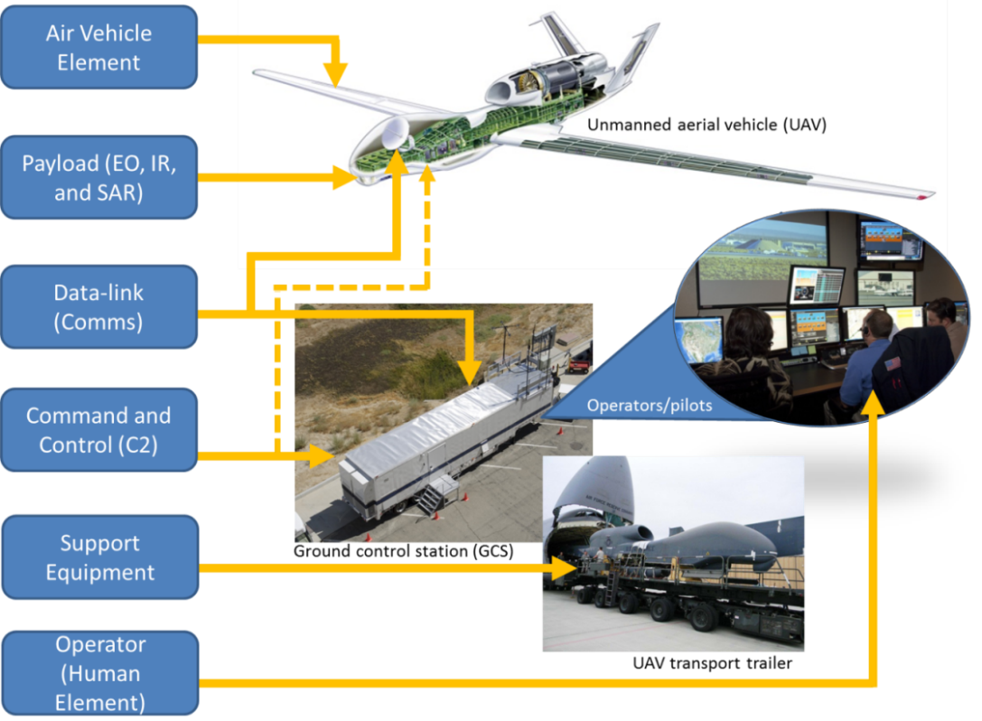
Figure 2. Description phrase to be used as title and description. [If not original] Reprinted [or adapted] from Title (page number), by Author first initial. Second initial. Surname, year, place of publication: Publisher. Copyright [Year] by the Name.

