IRT Test Section and Models
Ice-accretion testing was carried out at the NASA Glenn Icing Research Tunnel located in Cleveland, Ohio. The IRT is a closed-return, refrigerated wind tunnel that simulates flight through an icing cloud at pressure-altitudes near sea level. Three models were tested in IRT for this program: Inboard, Midspan, and Outboard. Each model was mounted vertically in the test-section and spanned the entire height as shown in Figure 1. The model base plate was bolted to the turntable for angle of attack adjustment. Due to the large size of the models, the model base plate extended beyond the outer periphery of the turntable. Thus, there was a small gap of approximately 0.25 in. between the test-section floor and the model base plate. There was also a small gap of approximately 0.25 in. between the top of the model main element and the test- section ceiling. The model was also supported at the ceiling interface with a 1.0 in. diameter pin located at the model center of rotation. The gaps between the model and the floor and ceiling were significantly larger for the flap to accommodate flap angles from 0 to 30 deg.
Each model was comprised of a main element, single-element slotted flap and removable leading-edge section. Some details of the model geometries are shown in Table 1 including the upper and lower surface extents of the full-scale leading edge. The main element and flap were instrumented with three streamwise rows of surface pressure taps that were located at spanwise stations 18, 36, and 54 in. above the test-section floor. Three thermocouples were installed inside the main element structure and these temperatures were monitored to ensure that the model temperature was in equilibrium with the surrounding air. There were two different interchangeable leading edges for each model. One leading edge was used for surface-pressure measurements and was instrumented with pressure taps in three streamwise rows corresponding to the spanwise stations on the main element and flap. The other leading edge was used for icing tests and thus has a completely smooth exterior surface. The removable leading edges were made from 0.090 in. thick aluminum that was stretch-formed to the desired airfoil coordinates and then hard anodized to improve the surface durability. For the icing leading edge, five thermocouples were located on the inside surface of the skin. Twelve thermocouples were installed in various locations beneath the flap heater to monitor the skin temperature.

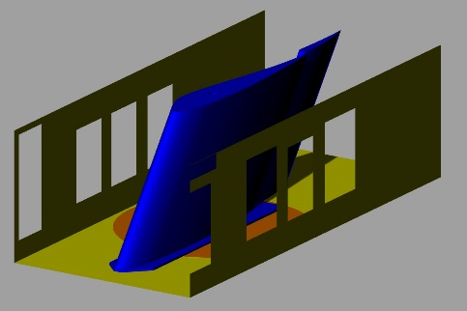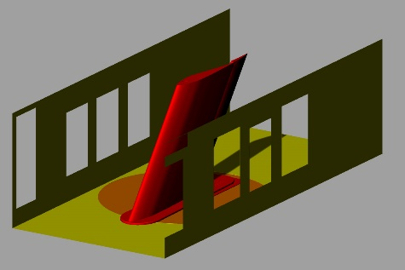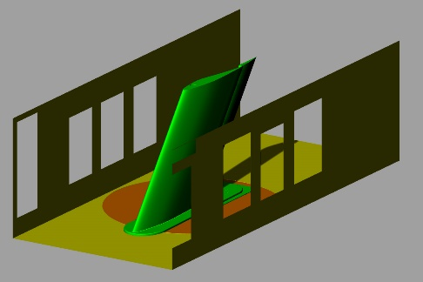
Fig 1. CRM65 models installed in the IRT test-section; from left to right: Inboard model, Midspan model and Outboard model.

Table 1. IRT model key dimensions
 | Inboard | Midspan | Outboard
CRM65 Semispan Location | 20% | 64% | 83%
Full-Scale (FS) Normal Chord, cFS (in.) | 297.9 | 122.7 | 91.3
Full-Scale (FS) Streamwise Chord (in.) | 260.3 | 135.7 | 100.7
Upper-Surface FS Leading-Edge Extent (x/cFS) | 0.04 | 0.10 | 0.17
Lower-Surface FS Leading-Edge Extent (x/cFS) | 0.06 | 0.10 | 0.15
Model Scale Factor (cFS/cHyb) | 2.25 | 2.0 | 1.5
Hybrid Model Normal Chord, cHyb (in.) | 132.4 | 61.4 | 60.9
Hybrid Flap Normal Chord (in.) | 32.7 | 15.1 | 15.0
Hybrid Model Streamwise Chord (in.) | 161.8 | 74.6 | 74.0
Hybrid Flap Streamwise Chord (in.) | 41.1 | 18.7 | 18.8
Upper-Surface FS Leading-Edge Extent Streamwise (in.) | 15.0 | 15.4 | 19.5
Upper-Surface FS Removable Leading-Edge Extent Streamwise (in.) | 11.2 | 12.3 | 11.4
Lower-Surface FS Leading-Edge Extent Streamwise (in.) | 22.4 | 15.4 | 17.2
Lower-Surface FS Removable Leading-Edge Extent Streamwise (in.) | 14.9 | 15.4 | 13.8

Figure 2 shows the Inboard IRT model as installed in the test section. The center of the mounting pin on the top of the model coincides with the center of the turntable. The CAD files of the IRT models are included in the database. The origin of the model coordinate systems (where x,y,z = 0) is located at the airfoil highlight location at top of the floor base plate, as shown in Figs. 3-5. The Inboard model base plate was 1” thick while the Midspan and Outboard model base plates were 1.25” thick. With the 0.25” gap between the tunnel floor and the baseplate, the origin was 1.25” above the floor for the Inboard model, and 1.5” above the tunnel floor for the Midspan and Outboard models, as shown in Figs. 3-5.
The as-built pressure tap ID and locations for the models are shown in Tables 2-10. These coordinate are in the model coordinate system, with the origin at the airfoil highlight location at the top of the floor base plate.
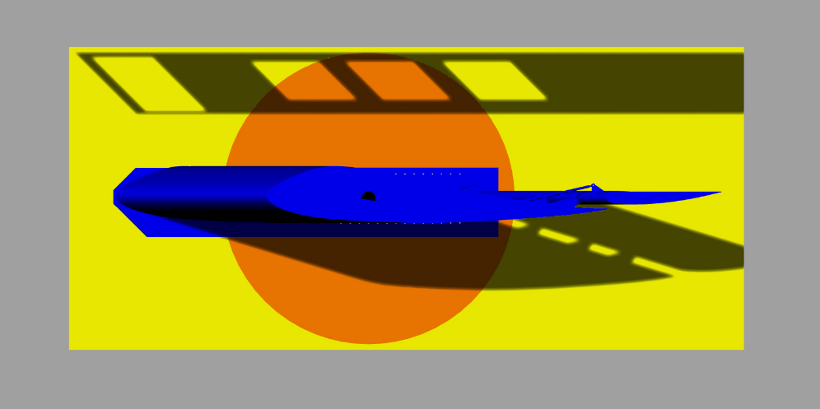
Fig. 2 Top View of the IRT model

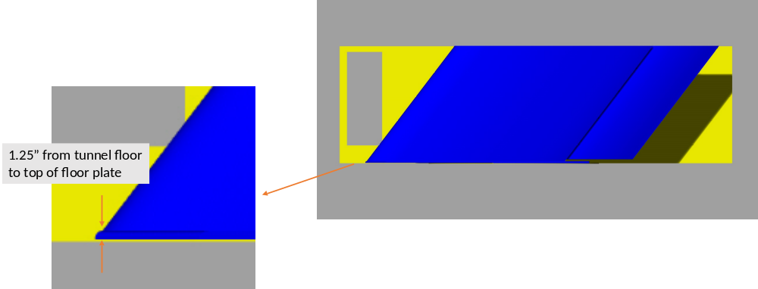
Fig. 3 Side view of Inboard Model

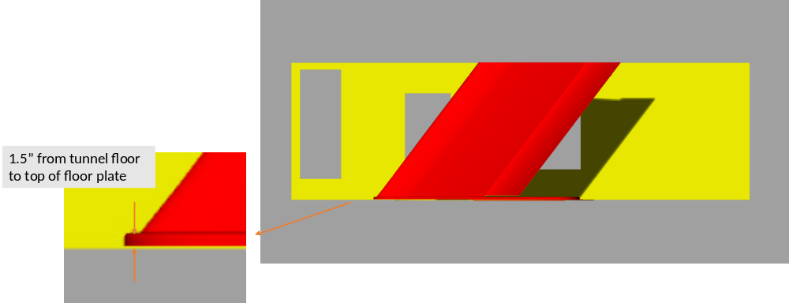
Fig. 4 Side view of Midspan Model
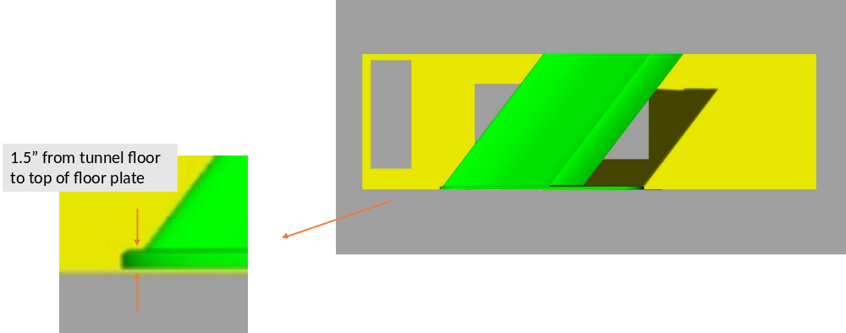
Fig. 5 Side view of Outboard Model

Table 2 Inboard Model Pressure Taps – 18” Span Station
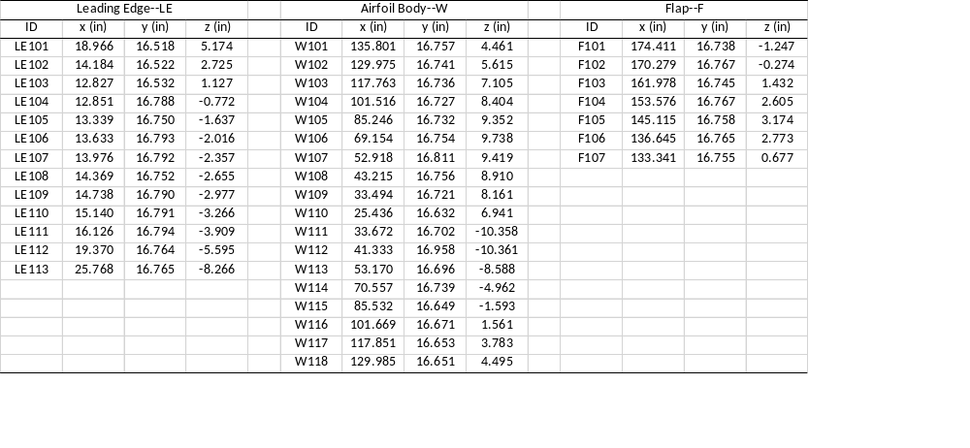

Table 3 Inboard Model Pressure Taps – 36” Span Station
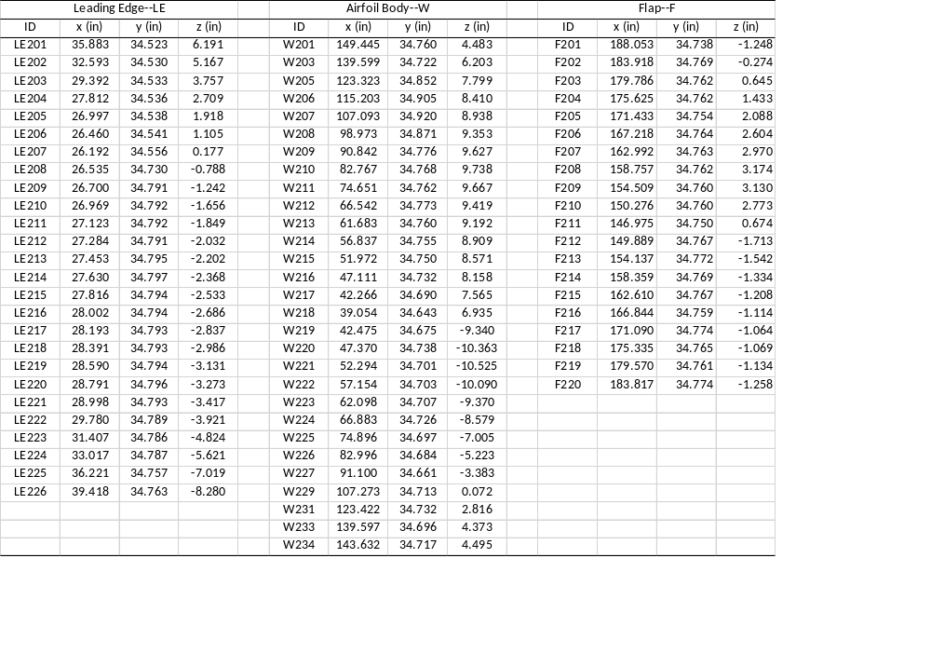

Table 4 Inboard Model Pressure Taps – 54” Span Station
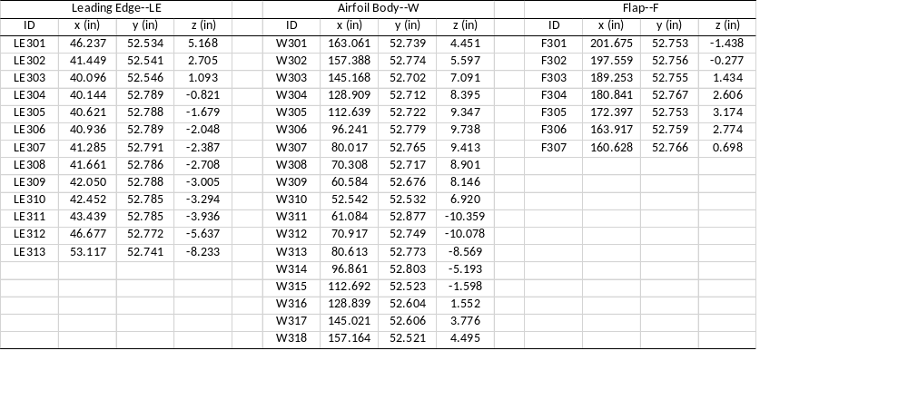

Table 5 Midpan Model Pressure Taps – 18” Span Station
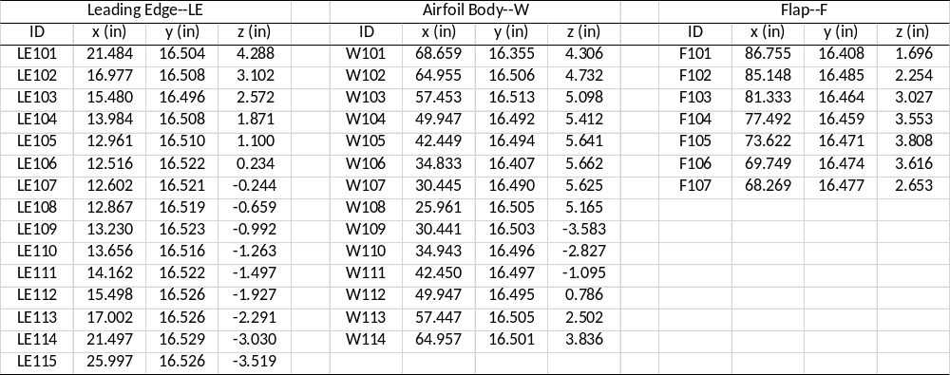

Table 6 Midpan Model Pressure Taps – 36” Span Station
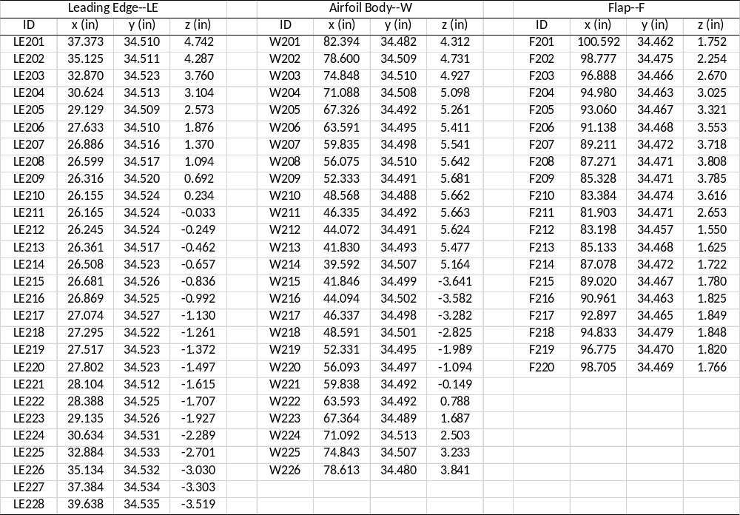

Table 7 Midpan Model Pressure Taps – 54” Span Station
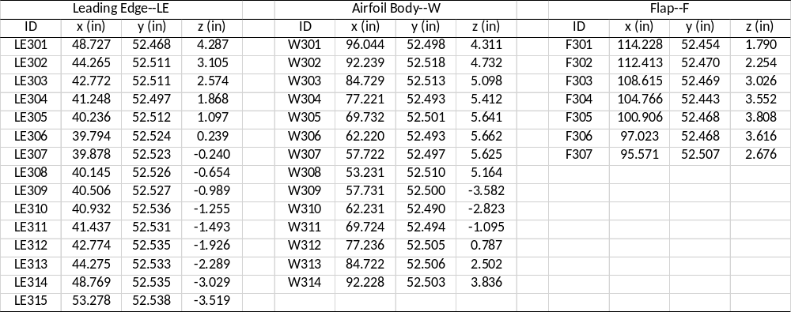

Table 8 Outboard Model Pressure Taps – 18” Span Station
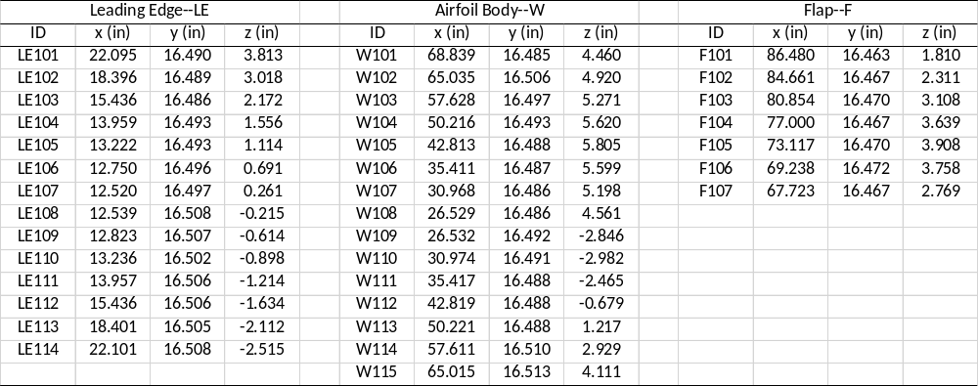

Table 9 Outboard Model Pressure Taps – 36” Span Station
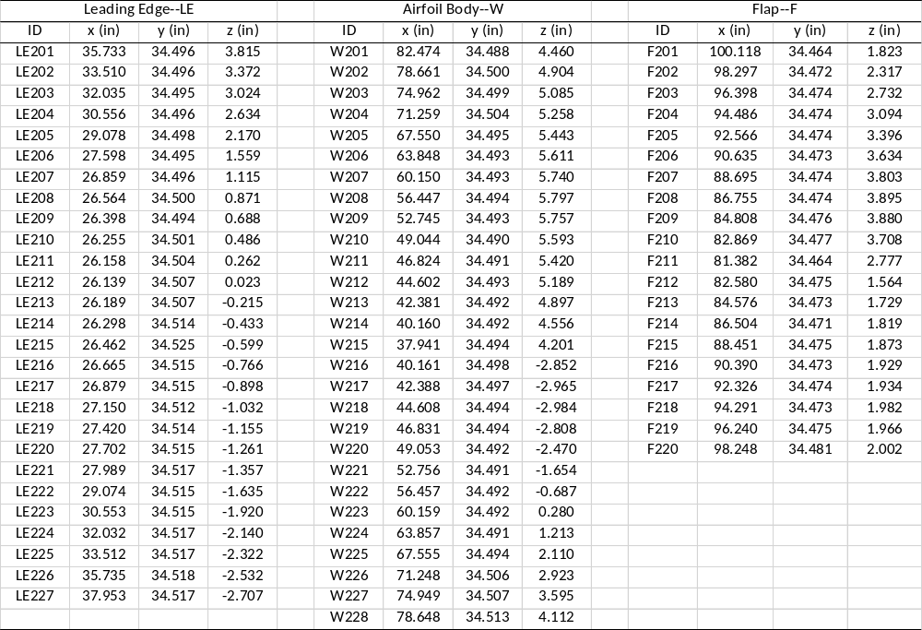

Table 10 Outboard Model Pressure Taps – 36” Span Station
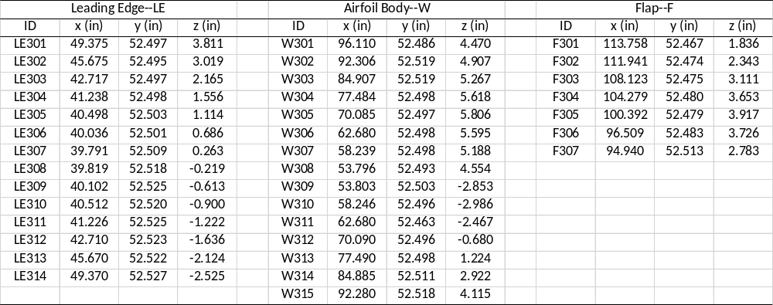

Experimental Methods
The models were tested in three separate test campaigns. The Midspan model was also utilized for a brief two-day test campaign approximately five months later. Each model was initially installed in the IRT test section with the pressure-instrumented leading edge. The model surface pressures were measured over a large range of angle of attack and flap deflections in order to track the location of the attachment line at the spanwise station 36 in. above the test-section floor (model centerline). The surface pressure data from these runs are included in this database. At the conclusion of these aerodynamic tests, the pressure-instrumented leading edge was removed and the icing leading edge was installed. For icing tests, the desired temperature and speed conditions were established with the appropriate time allotted for the model and tunnel to thermally equilibrate. The icing spray cloud was turned on for the desired period of time and then the tunnel was shut down to allow for documentation of the ice accretion. Photographs were taken first, followed by 3-D digital measurement using a laser-based scanning system In some cases, a section of the ice was removed (over the center 10” of the span) from the model and weighed after the 3-D measurements were completed.
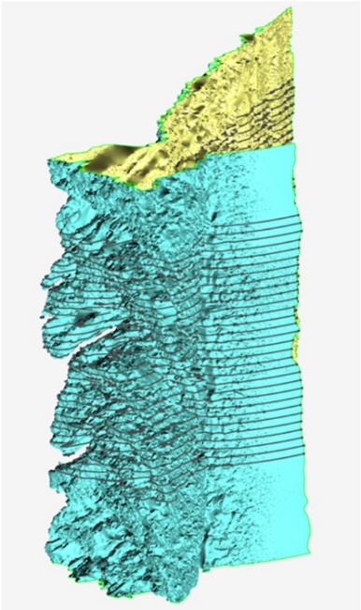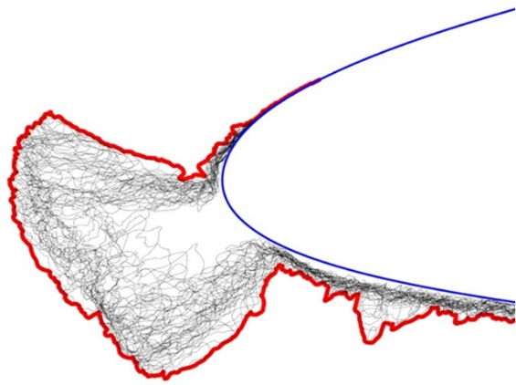
Figure 6.—Schematic description of process used to determine Maximum Combined Cross-Section (MCCS) of the 3-D ice accretion.

Many of the ice accretions observed during the IRT test campaigns were highly 3-D, such that any type of 2-D description is limited. Given that icing simulation tools typically provide 2-D ice-shape cross-sections, results of this type are required for comparison. The approach that was used for this paper was to take 31 section cuts through the 3-D scan of the ice accretion perpendicular to the wing leading edge as shown in Figure 6. These 30 section cuts were taken at a spacing of 0.2 in., thus covering 6 in. of ice accretion along the leading edge near the model centerline, 36 in. above the floor. The section cuts were projected onto a single plane and the maximum outer boundary was obtained. The resulting Maximum Combined Cross Section, or MCCS, represents the outermost extent of the ice over that 6-in. segment. The 6-in. segment was determined to be sufficient to capture all of the significant features of the ice accretions in these test campaigns. The MCCS is considered to be equivalent to the traditional hand-tracing method that typically results in the maximum outer boundary of an ice accretion. Traditionally, digitized hand tracings of ice accretion have been the basis for evaluation of icing simulation codes such as LEWICE3D.
All model and facility data were recorded on the IRT Escort D data system. The model data included the surface pressures, thermocouple temperatures and flap angle potentiometer described in the previous paragraphs. The facility data included the aerodynamic flow conditions, icing cloud parameters from the spray bars and temperatures. During the ice-accretion runs, these data were acquired at a rate of one measurement per second or one measurement per 10 sec depending upon the duration of the icing spray. The data acquisition was automatically triggered with the initiation of the spray and concluded with termination of the spray. The model surface pressure data were acquired with an Electronically Scanned Pressure (ESP) system. Each pressure tap was connected to an available port on a 5 psid ESP module. The pressure coefficient was calculated using the average static and differential pressures measured on the North and South Pitot-static probes in the bellmouth. No correction or test-section calibration was applied to these pressures. The ESCORT variable definition files are included in this database.
In addition to these measurements, surface oil flow visualization was also performed for the Inboard and Midspan models in the dry, or un-iced, configuration. The flow visualization was used to identify any regions of significant flow separation that was an important concern during the hybrid model design phase. The upper surface of the main element and flap was covered in flat-black, self-adhesive contact paper. The contact paper provided a smooth background surface with uniform color that greatly improved the flow visualization images. A light coat of motor oil was then applied to the upper surface. Automotive type fluorescent dye was added to mineral oil and applied to the model with sponge rollers. After a uniform covering of the dyed oil was achieved, the model was set to the desired incidence and flap angles. The tunnel was started and run at the desired speed for 2 to 3 min to allow the surface oil to reach a time- averaged pattern. After the tunnel was stopped, photographs were taken under UV-black light illumination.

Aerodynamic and Icing Test Conditions
The aerodynamic and icing test conditions were based upon the in-flight icing mission scenarios for the CRM65 airplane. There were at least seven different mission scenarios that were considered during the model design phase. In planning for the IRT test campaigns, three of these scenarios were selected as the reference conditions and are summarized in Table 11. All of the cases are for the airplane configured with flaps up which is consistent with the existing CRM65 geometry used for this work. The WB33 and WB41 cases are holding conditions in App. C continuous maximum icing. The WB33 case was a low gross weight (LGW) condition. The WB41 case had a slightly higher angle of attack and lower speed due to the high gross weight (HGW). The WB52 case is a descent condition and thus had a lower angle of attack and significantly reduced exposure time to the icing conditions.
Prior to the conduct of the testing, it was recognized that the speeds shown in Table 11 were most likely unrealistic, particularly for the Inboard model due to model size. Therefore, this model was tested in the first campaign and it was found that the optimum speed for icing tests was 130 knots for each case shown in Table 11. The maximum obtainable speeds were slightly higher, particularly for the WB52 case since this had the lowest angle of attack. It was determined that some margin on fan power was required and that running all three cases at the same speed was a useful simplification. Since a key objective of this work was to simulate the ice accretion that would build up on the CRM65 airplane wing, identical icing conditions including the speed of 130 knots were used for all three models. A limited set of conditions at higher speeds were also performed for the Midspan and Outboard models since these models could achieve the speeds shown in Table 11.

Table 11 CRM65 icing scenarios.
Case | Flight phase | Weight | Angle of attack  deg. | Static pres.  KPa | Mach | TAS  knots | Total temp.  °C | Static temp.  °C | MVD  μm | LWC  g/m3 | Exposure time,  min.
WB33 T-4 | Hold | LGW | 3.7 | 69.7 | 0.36 | 232 | 3.2 | –4.0 | 20 | 0.55 | 45.0
WB33 T-6 | Hold | LGW | 3.7 | 69.7 | 0.36 | 231 | 1.1 | –6.0 | 20 | 0.51 | 45.0
WB33 T-13 | Hold | LGW | 3.7 | 69.7 | 0.36 | 228 | –6.1 | –13.0 | 20 | 0.36 | 45.0
WB33 T-25 | Hold | LGW | 3.7 | 69.7 | 0.36 | 223 | –18.4 | –25.0 | 20 | 0.17 | 45.0
WB41 T-6 | Hold | HGW | 4.4 | 84.3 | 0.35 | 225 | 0.6 | –6.0 | 20 | 0.51 | 45.0
WB41 T-13 | Hold | HGW | 4.4 | 84.3 | 0.35 | 222 | –6.6 | –13.0 | 20 | 0.36 | 45.0
WB41 T-25 | Hold | HGW | 4.4 | 84.3 | 0.35 | 217 | –18.9 | –25.0 | 20 | 0.17 | 45.0
WB52 T-6 | Descent | Nominal | 2.1 | 84.3 | 0.41 | 263 | 3.1 | –6.0 | 20 | 0.51 | 4.0
WB52 T-13 | Descent | Nominal | 2.1 | 84.3 | 0.41 | 259 | –4.1 | –13.0 | 20 | 0.36 | 4.0
WB52 T-25 | Descent | Nominal | 2.1 | 84.3 | 0.41 | 253 | –16.5 | –25.0 | 20 | 0.17 | 4.1

The reference cases listed in Table 11 along with the speed limitation of 130 knots required modifications to the aerodynamic and icing conditions for the IRT tests. Further simplifications to the matrix were also performed in order to generate ice accretion that was more readily suited to icing-code evaluation.
The resulting IRT test conditions are shown in Table 12. Run ID 1 through 8 reflect the variation in temperature with all other conditions held constant. The 29 min exposure time for these cases resulted from an approximate scaling of the 45 min exposure shown for the WB33 T-13 flight reference case in Table 11. Run ID 9 in Table 12 resulted from a direct scaling of the WB33 T-25 flight reference case in Table 11. Run ID 10, 11, and 11.1 were short-duration exposures designed to look at ice roughness characteristics in the early stages of ice build-up. Run ID 12 and 13 were included to explore the effect of larger drop sizes on the ice accretion characteristics. Run ID 14 and 15 were scaled equivalents to Run ID 4 with a smaller drop size. Run ID 18 was identical to Run ID 4, but at the WB41 angle of attack = 4.4 deg. Run ID 21 and 22 were identical to Run ID 3 and 4, but at the WB52 angle of attack = 2.1 deg. Run ID 23 was scaled directly from the WB33 T-6 case in Table 11. The remaining conditions were only run on the Midspan or Outboard models and were included to evaluate effects of airspeed and model incidence. In addition to the conditions listed in Table 12, numerous repeat runs were performed for each of the three models. Ice-accretion repeatability was verified during the test campaigns by performing a direct comparison of the 3-D scan data.

Table 12 CRM65 IRT test conditions.
Run ID | Angle of attack,  deg. | Inboard flap,  deg. | Midspan flap,  deg. | Outboard flap,  deg. | TAS,  knots | Total temp.,  °C | Static temp.,  °C | MVD,  μm | LWC,  g/m3 | Exposure time,  min
1 | 3.7 | 13.7 | 25.0 | 14.0 | 130 | 1.0 | –1.2 | 25 | 1.00 | 29.0
2 | 3.7 | 13.7 | 25.0 | 14.0 | 130 | –1.4 | –3.6 | 25 | 1.00 | 29.0
3 | 3.7 | 13.7 | 25.0 | 14.0 | 130 | –3.8 | –6.0 | 25 | 1.00 | 29.0
4 | 3.7 | 13.7 | 25.0 | 14.0 | 130 | –6.3 | –8.5 | 25 | 1.00 | 29.0
5 | 3.7 | 13.7 | 25.0 | 14.0 | 130 | –8.7 | –11.0 | 25 | 1.00 | 29.0
6 | 3.7 | 13.7 | 25.0 | 14.0 | 130 | –11.2 | –13.5 | 25 | 1.00 | 29.0
7 | 3.7 | 13.7 | 25.0 | 14.0 | 130 | –15.0 | –17.2 | 25 | 1.00 | 29.0
8 | 3.7 | 13.7 | 25.0 | 14.0 | 130 | –23.8 | –26.0 | 25 | 1.00 | 29.0
9 | 3.7 | 13.7 | 25.0 | 14.0 | 130 | –17.9 | –20.1 | 25 | 0.60 | 23.0
10 | 3.7 | 13.7 | 25.0 | 14.0 | 130 | –17.9 | –20.1 | 25 | 0.60 | 2.5
11 | 3.7 | 13.7 | 25.0 | 14.0 | 130 | –1.4 | –3.6 | 25 | 1.00 | 2.5
11.1 | 3.7 | 13.7 | 25.0 | 14.0 | 130 | –6.3 | –8.5 | 25 | 1.00 | 2.5
12 | 3.7 | 13.7 | 25.0 | 14.0 | 130 | –20.0 | –22.2 | 35 | 0.60 | 24.0
13 | 3.7 | 13.7 | 25.0 | 14.0 | 130 | –20.0 | –22.2 | 35 | 0.60 | 2.5
14 | 3.7 | 13.7 | 25.0 | 14.0 | 130 | –6.7 | –8.9 | 20 | 1.40 | 26.5
15 | 3.7 | 13.7 | 25.0 | 14.0 | 130 | –4.9 | –7.2 | 20 | 1.00 | 37.4
18 | 4.4 | 13.7 | 28.0 | 17.0 | 130 | –6.3 | –8.5 | 25 | 1.00 | 25.5
21 | 2.1 | 13.7 | 14.0 | 9.0 | 130 | –3.8 | –6.0 | 25 | 1.00 | 29.0
22 | 2.1 | 13.7 | 14.0 | 9.0 | 130 | –6.3 | –8.5 | 25 | 1.00 | 29.0
23 | 3.7 | 13.7 | 25.0 | 14.0 | 130 | –3.1 | –5.3 | 27 | 0.91 | 45.0
23.1 | 3.7 | N/A | 25.0 | N/A | 130 | –3.1 | –5.3 | 27 | 0.91 | 32.0
30 | 3.7 | N/A | N/A | 14.0 | 232 | –11.2 | –18.3 | 20 | 0.30 | 25.3
31 | 7.5 | N/A | 0.0 | N/A | 130 | –6.3 | –8.5 | 25 | 1.00 | 29.0
32 | 3.7 | N/A | 25.0 | N/A | 180 | –2.0 | –6.3 | 24 | 0.65 | 32.0
34 | 2.1 | N/A | N/A | 9.0 | 247 | 1.2 | –6.8 | 22 | 0.38 | 30.0

