NASA Ames Balance Calibration Lab Request Form
(Include all applicable information)
Today’s Date |  |  |  | Date Required |  |  |  |  | Test Date
Test Name / Number |  |  |  |  |  |  | Organization/Company |  | Test Location
Principal Investigator |  |  | Phone |  |  |  | Mail Address
Test Engineer |  |  | Organization |  |  |  | Phone | Mail Address
Ames Balance Requested  Model, Size, NEMS |  |  |  |  |  |  | Balance Reserved  From To
If Balance is Supplied by User
Model, Size, Description
This Balance is used as
Primary / Backup
Provide Reduction Matrix  Yes / No |  |  |  |  | Type of Reduction Matrix
Balance Excitation Voltage |  |  |  |  | Balance Pin to Use (TASK Balances)
Deflection Data Required

GAGE  NAME | GAGE  CAPACITY | MAX LOAD  TO APPLY |  |  |  | SHUNT  %FS
N1
N2
S1
S2
RM
AX
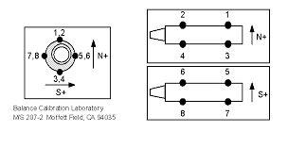
Diagram Task Pin Locations, Thick Side 3, 4, 7, 8
Combined Loads Required

Loading Method, Special Instructions, Additional Information

