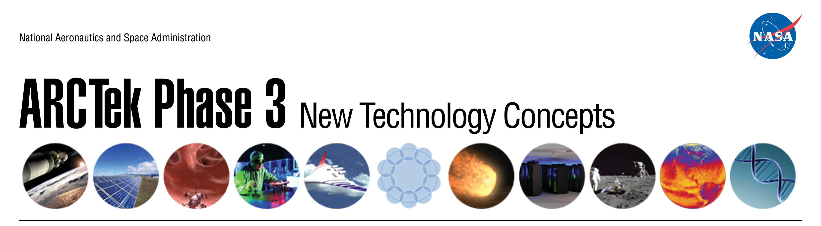

**October 16, 2012**

**NASA Ames Research Center**

**Building 152**

8:00AM Registration

8:30AM Welcome John Hines

Chief Technologist

Steven Zornetzer

Associate Center Director Technical

8:40AM Center Innovation Fund - HQ Perspective Minoo Dastoor

Program Executive

Center Innovation Fund

8:50AM Center Innovation Fund – 2013 John Hines

*Overview and Discussion*

9:50AM Space Technology Program John Hines

*Overview and Opportunities*

10:00AM Transition Opportunities John Hines

10:15AM CIF Success Story Ethiraj Venkatapathy

*Woven Thermal Protection System*

10:30AM Technology Concepts

*Materials Characterization in the Michael Oye*

*UCSC MACS Facility at NASA Ames*

*Launch Vehicle Compartment Venting B. Mclachlan / L. Hand*

*A Tool to Enable Technology Transfer for Misty Davies*

*Aerospace Concepts of Operation*

*Cellulose Paper Based Sensors Meyya Meyyappan*

10:30AM Technology Concepts (*continued*)

*Nanoscale Vacuum Tubes Meyya Meyyappan*

*Search Methods for Multidimensional Data Shawn Wolfe*

*Hypersonic Vehicle with Thrust Vector Control Jeffrey Logan*

*Spectroscopy of Organics in Space Andrew Mattioda*

*Life Support for a Lunar Garden Chris McKay*

*Reactivity Analyzer for Soil, Ices, and Regolith Tony Ricco*

*Gesture-Controlled Transparent Display Nghia Vuong*

*Health Monitoring of Vital Space and Claes Hedberg*

*Aeronautic Composite Structures*

*Force Sensors Based on Quantum Mechanical Bob Dahlgren*

*Tunneling: A new family of Metal-Oxide*

*Polymer Devices*

*Efficient Free Shear Layer Flow Control Upender Kaul*

*Automated Spacecraft Design K. Krishnakumar*

*Molecular Rayleigh Scattering to Measure Jay Panda*

*Fluctuations in Density, Velocity and Temperature in*

*Wind Tunnels*

*Subcritical Water Extractor C. Stoker / D. Willson*

*Multi-Mode Green Satellite Propulsion Laura Simurda*

*Softening of Rocks: Enabling Deeper Drilling Friedemann Freund*

*with Lower Power Consumption*

*CrowdSorcery David Guerrieri*

*Regolith Biocomposites: Novel Building David Loftus*

*Materials for Space*

*Earthquake Forecasting System Gerald Temple*

11:45AM Breakout Sessions All