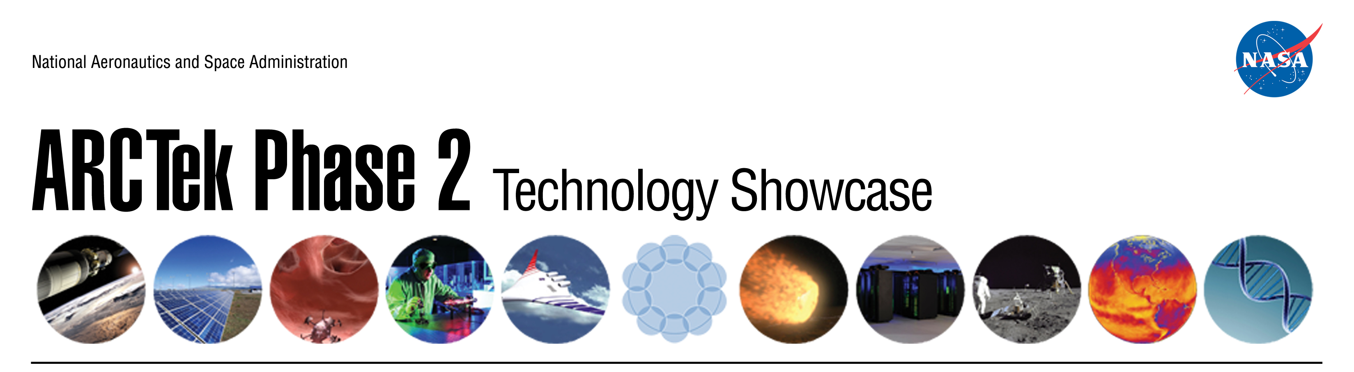

**June 7, 2012**

**NASA Ames Research Center**

**Building 152**

8:00AM Registration

8:30AM Introduction John Hines

8:45AM Ames Success Story Dan Rasky

*Phenolic Impregnated Carbon Ablator (PICA):*

9:00AM Center Innovation Fund – 2011 & 2012 Awardees

Lightning Rounds

*Woven TPS Ron Chinnapongse*

*Mars Micro-Mapping Mineralogical David Blake*

*Spectrometer (MµMMS)*

*Game Changing Transformable Paul Wercinski*

*Entry System Technology (TEST)*

*Computational Modeling of Ablative John Lawson*

*Materials: Application to Phenolic*

*Pyrolysis*

*Biologically Inspired Radiation-Reflecting Sylvia Johnson*

*Ablator (BIRRA) for Enabling Entry Descent*

*and Landing Missions to Gas Giant Planets*

*or Radiation-Intensive Environments*

*Kinetic-Integrated Thermal Protection System Sylvia Johnson*

*(KnITPS)*

*Deep Drilling Platform for Mars Exploration Carol Stoker*

*Low Cost Mars Sample Return Mission Study Carol Stoker*

*A Radiation Nose for Monitoring Radiation in Jinwoo Han*

*Space Missions*

*Lunar Plants Prototype for Moon Express Chris McKay*

*Micro-atmospheric Microwell Plate Technology Rocco Mancinelli*

*Novel Photobioreactor Development for Lee Prufert-Bebout*

*Space Applications*

*Pressure Sensitive Paint Applied to Flexible Models Laura Kushner*

*Manipulating the Toughness of Rocks Friedemann Freund*

*Through Electric Potentials*

*Synthetic Biology and Microbial Fuel Cells: John Hogan*

*Towards Self-Sustaining Life Support Systems*

*Encapsulation Technology for Delivery of David Loftus*

*Medical Therapeutics*

*Biocementation of Planetary Regolith David Loftus*

*A Synthetic Biology Tool Kit for Manned Lynn Rothschild*

*Missions Outside Low Earth Orbit*

*Materials Manufactured from 3D Printed Lynn Rothschild*

*Synthetic Biology Arrays*

*High Energy Density Additives for Hybrid Richard Jaffe*

*Fuel Rockets to Improve Performance and*

*Enhance Safety*

*Collapsible Space Telescope (CST) for Abe Rademacher*

*Nanosatellite Imaging and Observation*

*Advanced Exo Brake Development: Marc Murbach*

*Parachuting Small Payloads in a Single-Stage*

*from Low Earth Orbit*

*Surface Spectroscopy Center of Excellence Diane Wooden*

*A Framework for Telerobotics Across the Yildiray Yildiz*

*Time Delays of Space*

10:20AM Center Innovation Fund - 2011 & 2012 Awardees

*Poster Session*

11:20AM CIF - Selection Criteria / Wrap-Up John Hines