Geospatial Data Strategy

Pursuant to
Geospatial Data Act of 2018
Federal Aviation Administration Authorization Act (P.L. 115-254)

May 2021
Table of Contents
Executive Summary 3
1. Introduction 5
1.1. Legislative Direction 6
1.2. Planning Approach 6
1.3. NASA Roles and Responsibilities 11
2. Vision, Mission, and Guiding Principles 12
2.1. Vision 12
2.2. Mission 12
2.3. Guiding Principles 12
3. Goals and Enabling Objectives 13
3.1. Goal 1: Promote Geospatial Data Stewardship and Management Best Practices 13
3.2. Goal 2: Advance Open Data Systems to Promote Data Sharing, Discovery, and Reuse for All Geospatial Data Consumers 13
3.3. Goal 3: Lead Research and Development Efforts to Create, Cultivate and Promote Collaborative Partnerships Across the Geospatial Community 13
3.4. Goal 4: Empower Earth Science Communities to Realize Untapped Potential in the Geospatial Data Science Field 14
4. Implementation 14
5. Reporting 14
6. Conclusion 15
7. Appendix 16
7.1. Strategy Planning Approach 16
7.1.1. Data Use 16
7.1.2. Data Management 17
7.1.3. Data Infrastructure 17
7.1.4. Data Sharing 18
7.1.5. Data Administration and Governance 18
7.1.6. Records Preservation 19
7.2. Geospatial Data Act Covered Agency Responsibilities 20
7.3. Crosswalk NSDI Goals with NASA Geospatial Strategy Goals 21
7.4. List of Acronyms 22

Executive Summary
Since its founding in 1958, NASA has embraced the idea that the sharing of scientific data provides the best return on investment for the scientific community, for the agency itself, and for the United States more broadly. Open sharing of data and information increases scientific transparency and reproducibility as well as encourages reuse of data for a wide variety of applications. This commitment to open data initiatives has made NASA a leader both within the United States and internationally.
Evidence-based policies and knowledge-driven decisions are vital to advance NASA’s missions, which include:
- Enable human expansion across the solar system;
- Support growth of the Nation’s economy in space and aeronautics;
- Increase the understanding of the universe and our place in it;
- Work with industry to improve America’s aerospace technologies; and
- Advance American leadership.
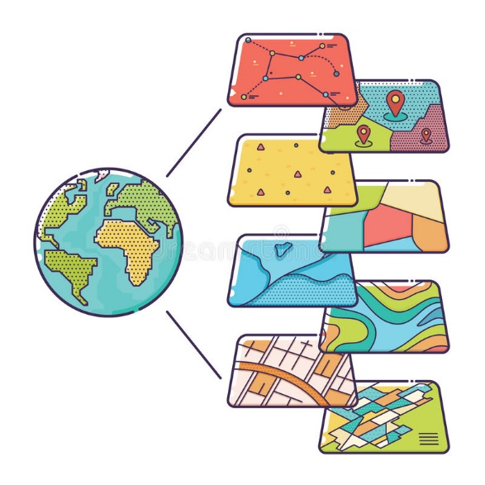
Geospatial, or location-based, information is integral to the greater policy development, evaluation, and decision making that underpins NASA’s missions. For example, an awareness of environmental conditions, energy resources, or the spatial trends of pandemic outbreaks all benefit from carefully curated geospatial data.
Figure 1 Geospatial Information Contains Location-Based Metadata Attributes
Geospatial data is used at NASA in a variety of ways. For example, NASA’s images of weather systems help forecasters predict the path of tropical storms, and NASA’s satellite data records are combined with other agency’s economic, climate and agriculture activities to help the Agency track the geographic spread of the COVID-19 virus. Geospatial information is also used locally to define and manage real property and environmental resources, which help the Agency arrange logistics for personnel moves, respond to emergencies, plan for future expansions, define safety procedures, and maintain security perimeters around NASA facilities.
The Geospatial Data Act of 2018 (GDA) seeks to foster efficient, government-wide management of geospatial data—objects, events, or phenomena that have a location on the surface of the Earth—technologies, and infrastructure. The GDA requires that covered agencies shall “prepare, maintain, publish, and implement a strategy for advancing geographic information and related geospatial data and activities appropriate to the mission of the covered agency, in support of the strategic plan for the National Spatial Data Infrastructure prepared under section 755(c).”
This NASA Geospatial Data Strategy ensures effective execution of the NASA mission and satisfies the requirements of the GDA and the National Spatial Data Infrastructure (NSDI). The management of geospatial information is a joint responsibility between NASA’s Earth Science Data Systems (ESDS) Program and the Office of Strategic Infrastructure (OSI) with support from the Chief Data Officer (CDO), the Office of the Chief Information Officer (OCIO) and the National Archives and Records Administration (NARA). Together, these groups drive key tasks to help NASA collect, manage, distribute, and archive its vast collection of geospatial information sets.
Central to the implementation of this strategy is to ensure geospatial data and information is used, shared, produced, and managed in both effective and collaborative ways across the enterprise and beyond. To do so, NASA must continue to reduce barriers to innovation by making geospatial data assets and services available to the public whenever feasible. The Agency will continue to commit to providing data in an open, public, and electronic format to encourage consumers to use in data projects that span the commercial, public, and academic domains. Similarly, NASA must continue making progress on implementing polices, strategies, and trainings to educate the Agency’s workforce to better understand geospatial analytics and use advanced analytic capabilities.
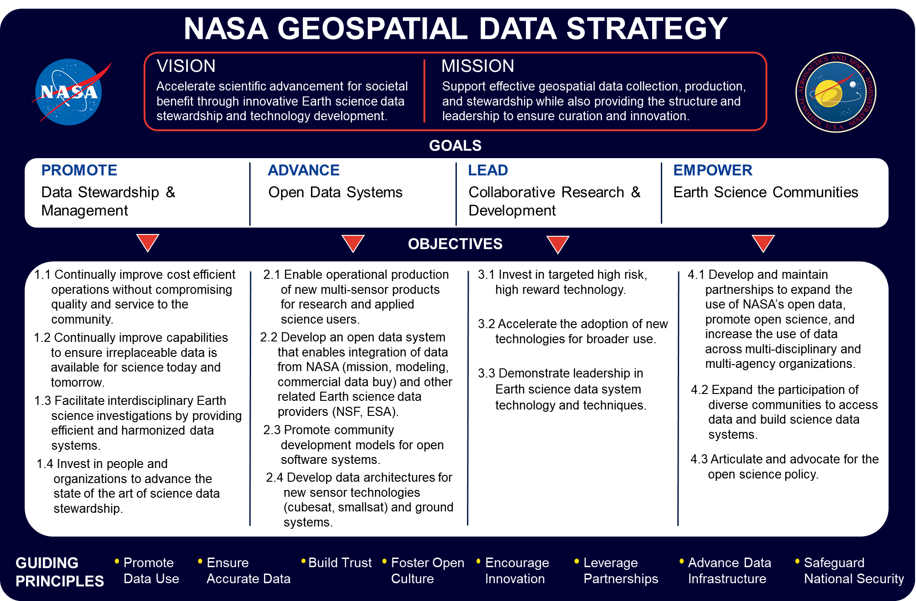
The NASA Geospatial Data Strategy rests on four overarching goals, which together aim to build an environment wherein geospatial data is credible, trusted, and supports the NASA mission (Fig 2). NASA’s CDO, which resides within the reporting structure of the Business Innovation Office, shall work in parallel with the OCIO to oversee the implementation of these strategic goals and monitor compliance with the GDA. All organizations within NASA shall report on progress towards achieving these goals and will work to foster collaborative partnerships across the Agency and across the entire Federal geospatial community.

Figure 2 NASA Geospatial Data Vision, Mission, Goals, and Objectives

Introduction
Each day, hundreds of thousands of NASA personnel, contractors, partners, and members of the public access some part of NASA’s information technology (IT) infrastructure, a complex array of information systems with components geographically dispersed around the globe. Currently more than 17,000 civil servants and 40,000 contractors work at nine NASA Centers and one Federally Funded Research and Development Center, as well as several smaller component facilities. Additionally, NASA collaborates with space agencies around the world and has deep partnerships with researchers, engineers, academics, and scientists worldwide. NASA also has an important mission to engage with students around the world, offering them opportunities to learn from and partner with NASA on its missions.
As part of its mission, NASA drives advances in science, technology, aeronautics, and space exploration to enhance knowledge, education, innovation, economic vitality and stewardship of Earth. The Agency leads innovative and sustainable programs with commercial and international partners to:
- Enable human expansion across the solar system;
- Support growth of the Nation’s economy in space and aeronautics;
- Increase the understanding of the universe and our place in it;
- Work with industry to improve America’s aerospace technologies; and
- Advance American leadership.
The influence of data in people’s lives is expanding exponentially. The increasingly critical role of data has encouraged federal agencies to recognize data as an organizational asset because of its influence on governmental, societal, and economic decisions. Geospatial data contains information that is associated to a location on Earth or contains spatial characteristics. NASA collects, analyzes, and uses geospatial information to make informed business decisions related to geographic places, mission centers, facility sites, and activities in the field.
NASA’s stewardship of geospatial data aligns with its vision “to discover and expand knowledge for the benefit of humanity”. Scientists and policymakers depend on the continuous flow of geospatial data to inform their decisions. This information supports many of today’s essential services, such as navigational assistance, weather forecasting, national disaster response efforts, environmental monitoring, transportation information and population distribution. As a pioneer in the scientific community, NASA is a primary leader in the amount of geospatial data collected, cataloged and shared with public and private communities.
Figure 3 NASA is a Primary Steward of Geospatial Data in the Public and Private Domains
Geospatial data serves an integral role in NASA’s core mission. NASA ensures that it has a clear geospatial strategy in place to harness the vast potential of geospatial data assets and to meet legislative requirements. This NASA Geospatial Data Strategy provides a roadmap that outlines the steps to complete the requirements of the Geospatial Data Act (GDA), strengthen the value of geospatial information across the Agency’s enterprise, curate relationships with partners to realize cost efficiencies, and empower the geospatial data community to provide effective and reliable mission support.

Legislative Direction
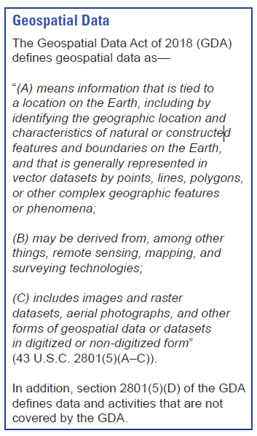
The Federal government recognized a need to organize and coordinate the collection and management of geospatial data, which culminated in the Office of Management and Budget (OMB) revising Circular A-16 in 1990 to establish the Federal Geographic Data Committee (FGDC) and include in the Circular not only surveying and mapping, but also related spatial data activities. A 2002 revised Circular called for continuous improvements in spatial data coordination and use of geospatial data, as well as clearly defined federal agencies and FGDC responsibilities in promoting the coordinated use, sharing, and dissemination of geospatial data nationwide.
The Executive Branch owned managing the challenges of coordinating and sharing geospatial data across varying levels of local and national organizations until the enactment of the GDA in 2018. The GDA and the Open, Public, Electronic, and Necessary (OPEN) Government Data Act of 2019, as part of the Foundations for Evidence-Based Policy Making Act, created a regulatory framework to address sharing geospatial data and ensuring it be openly available and usable to inform federal decision-making.
As defined in the Geospatial Data Act:
Covered agencies shall “prepare, maintain, publish, and implement a strategy for advancing geographic information and related geospatial data and activities appropriate to the mission of the covered agency, in support of the strategic plan for the National Spatial Data Infrastructure prepared under section 755(c).
Figure 4 GDA Definition of Geospatial Data
NASA has long incorporated the activities of responsible data collection, curation, dissemination and sharing into its core missions, strategic values, and day-to-day operations. The agency serves as a data steward in the scientific community, actively seeking opportunities to share data and information with commercial and international partners to advance space exploration and aerospace technologies.
This strategy supports the legislative requirements outlined in the GDA and leverages the template provided by the FGDC.

Planning Approach
Key agency activities in core programs that collect, use, and manage geospatial information were evaluated to determine the approach and define the goals and objectives for this strategic plan. This section provides a high-level overview of how NASA collects, uses, manages, shares, and preserves geospatial data. Further details on these topics are provided in Appendix 7.1 Strategy Planning Approach.
Since its founding in 1958, NASA has embraced the idea of open sharing of data and information to increase scientific transparency and encourage reuse of data for a wide variety of applications. This commitment to an open data initiative has made NASA a leader and a steward of scientific data both within the United States and internationally.
NASA’s Earth Science Data System (ESDS) collects, maintains, disseminates, and preserves petabytes of geospatial data for millions of users from around the world. The ESDS Program within the Science Mission Directorate (SMD) oversees the life cycle of NASA’s Earth science data and most agency geospatial datasets, from acquisition through processing and distribution.
Earth science and geospatial data are used in a variety of ways by NASA both internally and in partnership with external agencies and organizations today. The Agency’s Aqua satellite, as seen in Figure 5, provided forecasters with a visible image of Hurricane Isaias as it was intensifying in the Atlantic Ocean in August 2020. Within the Agency, NASA recently developed an Executive Decision Lens (EDL) solution in partnership with the U.S. Health and Human Services, the U.S. Department of State, and the U.S. Department of Agriculture. The EDL consolidated geospatial and demographic data assets to develop dashboards that combined federal workforce metrics with COVID-19 contract tracing tools and vaccination status data. The EDL dashboards helped the Federal Government understand the spread of the COVID-19 virus and make operational decisions for safely managing their work and workforce during the height of the pandemic (Figure 5). NASA, the European Space Agency (ESA), and the Japan Aerospace Exploration Agency (JAXA) similarly used geospatial data to create the COVID-19 Earth Observation Dashboard (Figure 6). This product integrates multiple satellite data records with analytical tools for tracking changes in air and water quality, climate, economic activity, and agriculture to help track the geographic spread of the COVID-19 virus.
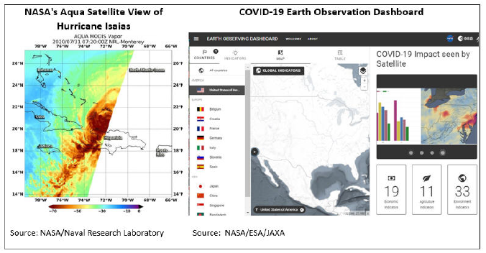
Figure 5 Examples of NASA Geospatial Data Use (Left: Aqua Satellite, Right: COVID-19 Earth Observation Dashboard)

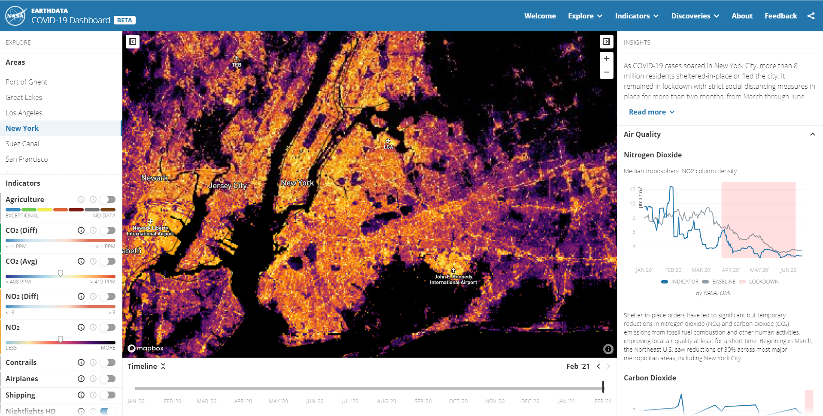
Figure 6 COVID-19 Earth Observation Dashboard (earthdata.nasa.gov/covid19)
The Earth Observing System Data and Information System (EOSDIS) is the core operational system within ESDS that provides end-to-end capabilities for managing NASA Earth science data from various sources. The EOSDIS is comprised of twelve discipline-specific Distributed Active Archive Centers (DAACs) that are relied upon by millions of users every year for access to NASA’s Earth science and geospatial data. The DAACs, operated collaboratively by NASA and contractor staff, are responsible for processing, archiving, and distributing NASA’s Earth science data. The primary website for access to all NASA Earth Science data located within DAACs is Earthdata Search (Figure 7), available at https://search.earthdata.nasa.gov/search.
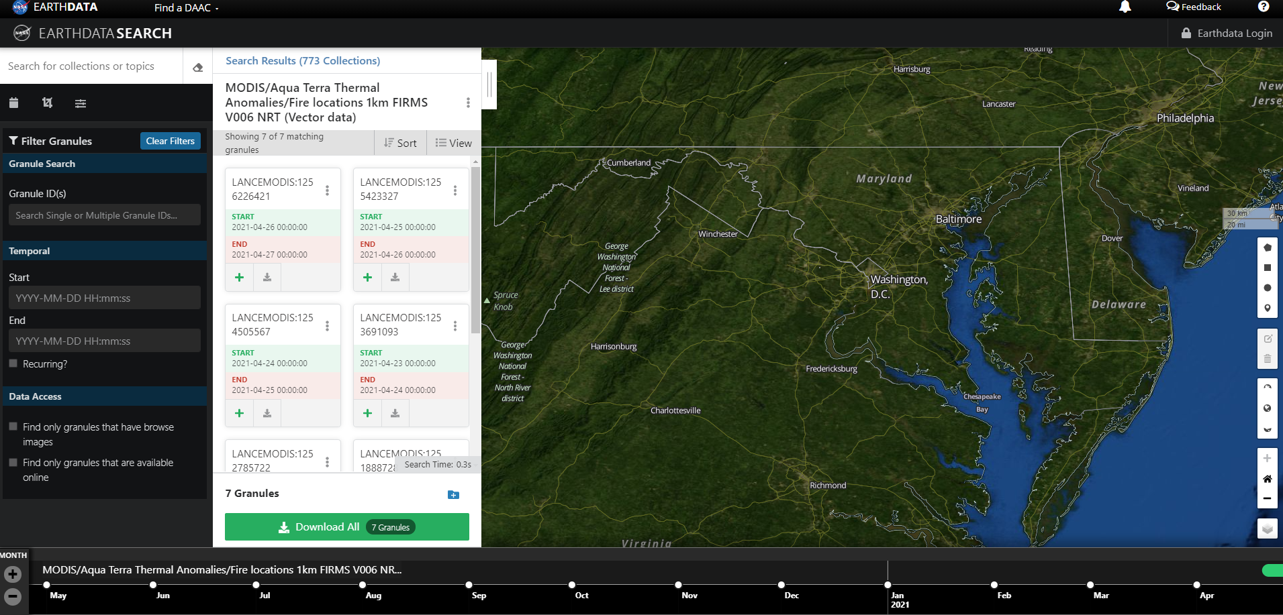
Figure 7 Earthdata Search Website
Since the founding of the EOSDIS in the early 1990s, NASA has been a leader in open geospatial data efforts both nationally and internationally. NASA’s data policies have stipulated from inception that satellite and geospatial data be made openly available to all users for research applications and commercial users. To align with this historical standard, the core components of the EOSDIS across all DAACs enable data discovery and reuse for a wide variety of audiences. These shared components include the Common Metadata Repository (CMR), Earthdata Search, Global Imagery Browse Services (GIBS), Worldview, and Earthdata Login.
NASA's CMR is a high-performance, high-quality, continuously evolving metadata system that catalogs all data and service metadata records for NASA's EOSDIS and is the authoritative management system for all EOSDIS metadata. These metadata records are registered, modified, discovered, and accessed through programmatic interfaces leveraging standard protocols and APIs. CMR tools and services include the CMR Application, Metadata Management Tool, and the Metadata Curation Dashboard. CMR is the backend behind the data search and discovery services found in Earthdata Search and the International Data Network.
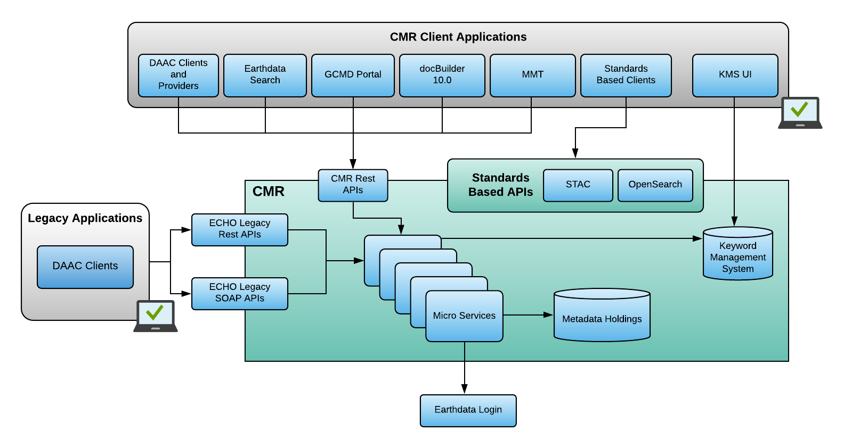
Figure 8 NASA Common Metadata Repository (CMR)
The specific mechanism by which data is promoted and shared with stakeholders across these shared services and tools is defined by a robust data infrastructure that was built to ensure data remain as findable, accessible, interoperable, and reusable (FAIR) as possible. As outlined in Figure 9, NASA’s geospatial data is first cataloged and linked through the NASA CMR, which is accessible from the Earthdata Search endpoint search.earthdata.nasa.gov/search. The CMR then populates the top-level Agency Open Data catalog, data.nasa.gov, which contains both spatial and non-spatial datasets that are accessible via APIs in machine-readable format. The Agency Open Data Catalog populates the Federal Catalog data.gov, which in-turn populates the FGDC Geoplatform.gov catalog, thus providing a multilevel integrated pathway for broad discovery and use of NASA geospatial data. Most of these data sets are openly available in FGDC sanctioned open data formats to the user community as soon as they are published to the network of data catalogs.
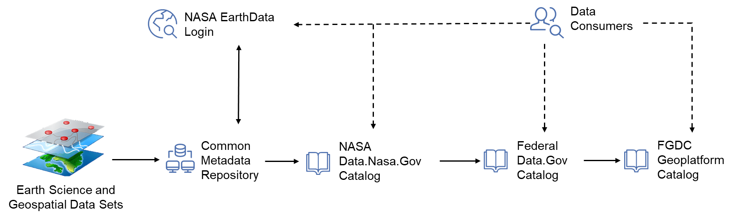
Figure 9 NASA Geospatial Data Catalog Open Data Sharing Infrastructure
NASA’s Office of Strategic Infrastructure (OSI) also uses geospatial data to execute its objective to ensure that the right infrastructure is available to meet NASA’s mission requirements. To accomplish this, the OSI uses geospatial data to manage assets and enhance infrastructure planning, procurement, build and deployment activities. More specifically, OSI uses geospatial data to identify, define, and catalog NASA’s real property and environmental resources. These efforts help OSI plan logistics for personnel moves, respond to emergencies, plan for future facility expansions, define safety procedures, and maintain security perimeters around NASA facilities.
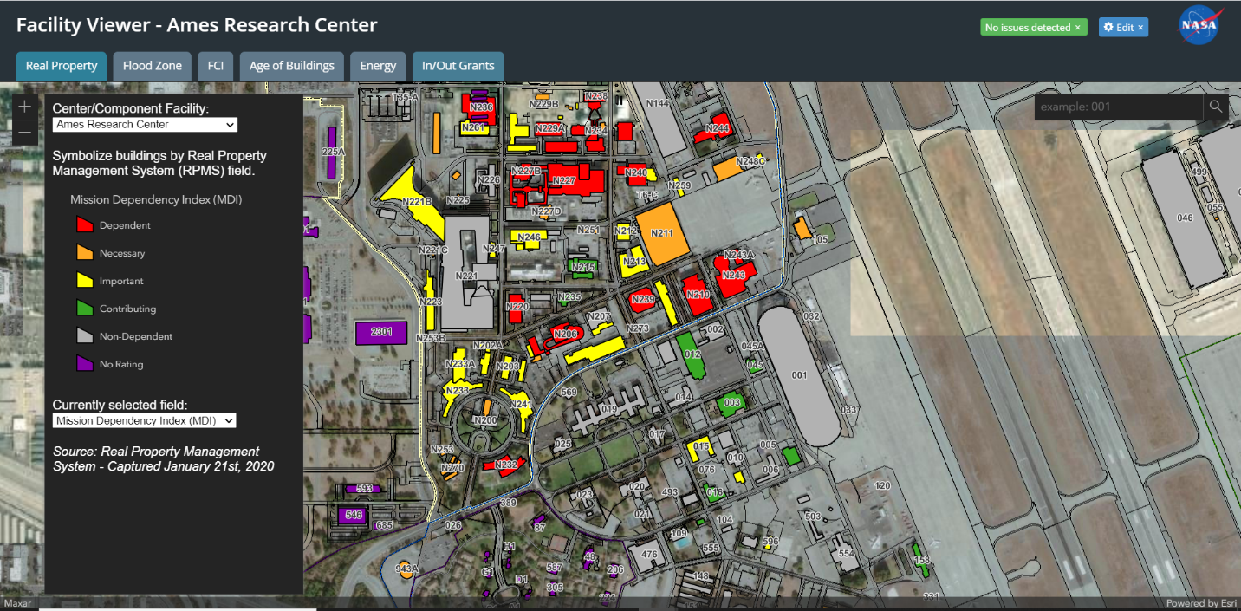
Figure 10 OSI Facility Management Data Dashboard of the Ames Research Center
OSI environmental data is also used to support National Environmental Policy Act (NEPA) projects, manage cultural resources such as historic buildings, districts, and surveyed areas, as well as maintain the Agency’s compliance with environmental structures such as wells, contaminated sites and contamination plumes.
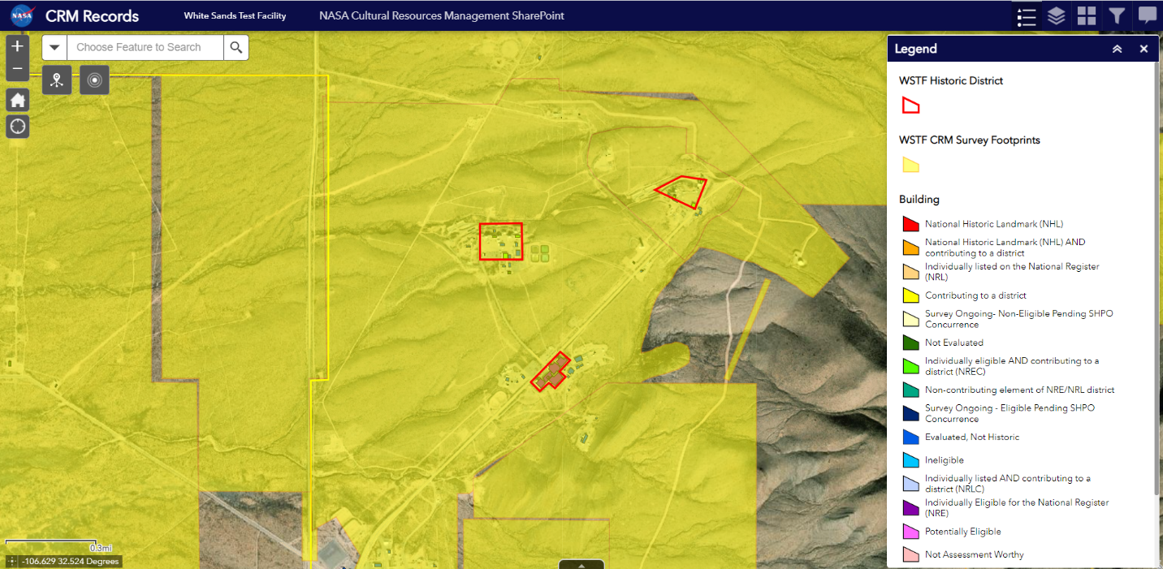
Figure 11 OSI Environmental Resource Data Dashboard
The geospatial data used by OSI is captured through multiple methods and data conversion programs, including GPS, orthophoto extraction, terrestrial and airborne Light Detection and Ranging (LIDAR) and Unmanned Aircraft Systems (UAS) collection. Much of each geospatial data collection is maintained only at the individual centers, and the data holdings vary greatly depending on the Center’s mission and investments.
Resources are allocated for these core data systems and responsibilities every year through congressional budget justifications. Additional resources are allocated to support the evolution of NASA ESDS to address an evolving ecosystem of geospatial data needs. This evolution includes aligning ESDS’s work plans with the Federal Data Strategy.

NASA Roles and Responsibilities
Broadly, geospatial data and records management responsibilities are divided among four key groups at NASA in addition to the National Archives and Records Administration (NARA), which is external to the Agency:
- The Office of the Chief Information Officer (OCIO) is responsible for the Agency’s Records Management Program and compliance with federal regulations and requirements. Within the OCIO, the Chief Data Officer (CDO) and Records Officer direct records management, including preservation.
- The Chief Archivist in NASA’s History Division provides archival and technical guidance for the management and preservation of historical records.
- The Earth Science Data Systems (ESDS) Program within the NASA Science Mission Directorate (SMD) oversees the life cycle of NASA’s Earth science data—from acquisition through processing and distribution. ESDS includes the Distributed Active Archive Centers (DAACs), which are responsible for processing, archiving, and distributing NASA’s science data. The data are stored at 12 DAACs located at NASA Centers, universities, and other Federal agencies and are organized according to science discipline or theme. ESDS also supports NASA in its participation in FGDC, including direct participation in FGDC committees and working groups, as well as support of the National Geospatial Data Asset (NGDA) Data Themes. NASA jointly manages three NGDA datasets with the United States Geological Survey. These datasets are included in the ‘Imagery’ theme community NGDA portfolio and include ASTER, Aqua MODIS and Terra MODIS. ESDS supports these three datasets, along with other NASA Earth observation data, as a national asset by providing efficient production and stewardship of these data. The ESDS Program ensures these datasets are discoverable in Geoplatform.gov.
- The Office of Strategic Infrastructure (OSI) manages geospatial data in support of NASA’s Centers, real property, and field locations.
- The National Archives and Records Administration (NARA) shares responsibilities for records management with NASA. NARA has general oversight responsibilities for preservation of permanent records that document the activities of the federal government; NASA is responsible for identifying and submitting lists of its records with a proposed disposition schedule to NARA. Representatives from both NASA and NARA develop a disposition schedule to ensure all NASA records are retained for the appropriate length of time.

Vision, Mission, and Guiding Principles
NASA’s vision and mission for geospatial data reflect the overall vision and mission of the agency, which are anchored around the themes of exploring, innovating and sharing information. Data is an integral component of the agency’s ongoing business operations and missions, and geospatial data is leveraged as a strategic asset across the Agency.

Vision
Accelerate scientific advancement for societal benefit through innovative Earth science data stewardship and technology development.

Mission
The Geospatial Data Strategy will support NASA in fulfilling the responsibilities of effective geospatial data collection, production, and stewardship while also providing the structure and leadership to ensure coordinated curation and innovation for the NASA mission.

Guiding Principles
To align with the FGDC and priorities set forth by the governing body of federal geospatial data assets, NASA has fully adopted the guiding principles outlined in the NSDI 2021-2024 Strategic Plan. These principles leverage recognized standards from relevant laws, policies, and best practices as well as reflect inputs from diverse geospatial communities.
- Promote the utilization of geospatial resources to improve insight and decisions making.
- Ensure that geospatial data are current, accurate, open, standards-based, findable, accessible, interoperable and reusable.
- Build trust by safeguarding privacy, confidentiality, and intellectual property and by ensuring ethical practices.
- Foster an open, inclusive, and collaborative culture across sectors.
- Encourage innovation and an environment of learning and accountability.
- Leverage resources, expertise, and investments through partnerships.
- Lead, support, and advance spatial data infrastructure globally.
- Safeguard national security and critical infrastructure.

Goals and Enabling Objectives
The goals and enabling objectives outlined in the following sections address data requirements defined in a variety of policies and regulations, including the Geospatial Data Act, the Evidence Based Policymaking Act, the OPEN Government Data Act, the National Spatial Data Infrastructure (NSDI) 2021-2024 Strategic Plan, and OMB Circular A-16. These laws provide the guidelines that govern federal data standards and policies, which include open data by default, inter-agency data sharing and standardized data formatting. These regulatory requirements, as well as NASA’s activities and leading initiatives in the data community, were used to inform NASA’s strategic goals and objectives.

Goal 1: Promote Geospatial Data Stewardship and Management Best Practices
NASA shall set the standard for efficient production and stewardship of science-quality data. The Agency shall also work to promote robust data management best practices throughout the data lifecycle to ensure geospatial data is findable, accessible, interoperable, and reusable (FAIR).
- Objective 1.1: Continually improve cost efficient operations without compromising quality and service to the community.
- Objective 1.2: Continually improve capabilities to ensure irreplaceable data is available for science today and tomorrow.
- Objective 1.3: Facilitate interdisciplinary Earth science investigations by providing efficient and harmonized data systems.
- Objective 1.4: Invest in people and organizations to advance the state of the art of science data stewardship.

Goal 2: Advance Open Data Systems to Promote Data Sharing, Discovery, and Reuse for All Geospatial Data Consumers
NASA shall advance open science data systems for the next generation of missions, data sources, and user needs. The Agency shall ensure open standards are based on interoperability to help drive geospatial data shared services for the commercial and scientific communities.
- Objective 2.1: Enable operational production of new multi-sensor products for research and applied science users.
- Objective 2.2: Develop an open data system that enables integration of data from NASA (mission, modeling, commercial data buy) and other related Earth science data providers (NSF, ESA).
- Objective 2.3: Promote community development models for open software systems.
- Objective 2.4: Develop data architectures for new sensor technologies (cubesat, smallsat) and ground systems.

Goal 3: Lead Research and Development Efforts to Create, Cultivate and Promote Collaborative Partnerships Across the Geospatial Community
NASA shall lead research and development of technology for management and analysis of complex Earth science data. The Agency shall enable and promote collaborative partnerships to meet the needs, priorities and circumstances for the geospatial data science community.
- Objective 3.1: Invest in targeted high risk, high reward technology.
- Objective 3.2: Accelerate the adoption of new technologies for broader use.
- Objective 3.3: Demonstrate leadership in Earth science data system technology and techniques.

Goal 4: Empower Earth Science Communities to Realize Untapped Potential in the Geospatial Data Science Field
NASA shall leverage the diversity of global Earth science communities to advance open science capabilities.
- Objective 4.1: Develop and maintain partnerships to expand the use of NASA’s open data, promote open science, and increase the use of data across multi-disciplinary and multi-agency organizations.
- Objective 4.2: Expand the participation of diverse communities to access data and build science data systems.
- Objective 4.3: Articulate and advocate for the open science policy.

Implementation
NASA’s Geospatial Strategic Plan provides a roadmap for the Agency to ensure geospatial data and information is used, shared, produced, and managed in both effective and collaborative ways across the NASA enterprise and beyond. This strategic plan serves as the foundation for an implementation plan. The implementation plan will offer a timeline for meeting the strategic goals and objectives outlined in Section 3, as well as details on the responsible parties, performance metrics, required resources, and related reporting requirements.
As GDA requirements are further defined, NASA will have additional decisions to make in collaboration with the FGDC, the results of which the Agency plans to assess during future reviews and audits. NASA’s Acting Chief Information Officer and Associate Administrator for the SMD shall take the following immediate next steps to utilize the Agency’s existing expertise in data management, align activities to the Federal Data, NSDI and NASA Data strategies, and ensure that geospatial data is appropriately considered for historical preservation:
- Appoint a senior agency official for geospatial information to coordinate with the FGDC and align NASA’s geospatial data strategy with the NSDI strategy, as well as assist in the development of the required data, metadata, and quality standards.
- Develop a unified Strategy Implementation Plan, or “Roadmap”, that defines detailed action items, milestones, and responsibilities for geospatial data management in support of missions across NASA.
- Develop records schedules in coordination with NARA for NASA’s historically significant geospatial data assets.
- Collaborate with NARA to determine if there is value in establishing affiliated data archive agreements for NASA’s remote sensing/earth observing geospatial data assets.

Reporting
NASA’s OCIO shall be responsible for managing the creation and submission of the reports required by law as defined in the GDA, with support from suborganizations within the Agency such as ESDS. The table below explains how NASA will fulfill these reporting requirements.
Type | Requirement | Description
Performance Report | 43 U.S.C. 2808(b)(1) | Each covered agency shall submit to the Committee an annual report regarding the achievements of the covered agency in preparing and implementing the strategy.
Performance Report | 43 U.S.C. 2808(c)(12) | Not less than once every 2 years, submit to Congress a report that includes the comments of the covered agencies and the responses of the Committee to the comments.
Budget Justifications | 43 U.S.C.(b)(2)(A) | Each covered agency shall include geospatial data in preparing the budget submission of the covered agency to the President.
Other Reports | 43 U.S.C. 2808(b)(2)(C) | Each covered agency shall prepare an annual report to Congress identifying Federal-wide geospatial data assets, as defined in OMB Circular A–16, as set forth in OMB memo M–11–03, Issuance of OMB Circular A–16 Supplemental Guidance
Audits | 43 U.S.C. 2808(c) | Not less than once every 2 years, the inspector general of a covered agency (or senior ethics official of the covered agency for a covered agency without an inspector general) shall submit to Congress an audit of the collection, production, acquisition, maintenance, distribution, use, and preservation of geospatial data by the covered agency

Conclusion
Geospatial data is an integral component of NASA’s core vision and mission. NASA aims to discover and expand knowledge of the universe for the benefit of humanity. In doing so, NASA continuously collects, creates, consumes, and disseminates geospatial data and information for use in mission activities and Agency operations. The Agency also actively seeks to share that information with the broader scientific community. The collective availability of geospatial data has allowed NASA and its partners to support field staff, assess global risks, allocate resources across geographic centers and missions, strengthen analytic processes, and execute scientific initiatives.
The goals and objectives outlined in this Geospatial Strategic Plan provide NASA with a framework by which it can define a structured roadmap from which the Agency’s vision for geospatial data can be achieved. Achieving this vision will require effective and robust data management paired with a strong relationship between data gatherers, data analysts, data stewards and data users to create an environment where NASA can build trust in and extract more value from its data, effectively set enterprise priorities, and achieve greater results across missions.

Appendix

Strategy Planning Approach
NASA has one of the world’s largest repositories of Earth science data, with thousands of geospatial datasets which includes hundreds of millions of files. NASA acquires, processes, preserves, and distributes observational Earth science data from spacecraft, aircraft, and in situ sensors to support Earth Science research focus areas. The programs at NASA’s Earth Science Data Systems and Office of Strategic Infrastructure have largely shaped NASA’s overall approach to an agencywide geospatial data strategic plan.
The Earth Science Data Systems (ESDS) Program within the Science Mission Directorate (SMD) oversees the life cycle of NASA’s Earth science data and most agency geospatial datasets, from acquisition through processing and distribution. ESDS includes the Distributed Active Archive Centers (DAACs), which are operated collaboratively by NASA and contractor staff, and are responsible for processing, archiving, and distributing NASA’s science data. The 12 DAACs are located at NASA Centers, universities, and other federal agencies and are organized according to science discipline or theme.
Additionally, NASA’s Office of Strategic Infrastructure (OSI) captures and utilizes geospatial data in a variety of formats and functions. The primary use of this data is for NASA facility operations and environmental resources management. Most of this data is maintained at the individual Center and site level, but their management and use can vary greatly depending on the mission and investments available at those Centers and sites. Localized Enterprise GIS systems are used at many Centers and sites to provide specific platforms with which to manage these geospatial data assets.
The programs at ESDS and OIS have largely shaped NASA’s overall approach to an agencywide geospatial data strategic plan.

Data Use
NASA leverages geospatial data to improve operations, organizational decision making, and scientific activities. Regarding operations, NASA uses geospatial data to create facility master plans, construct new facilities, perform maintenance and operations, mitigate disaster risk, ensure safety, and provide security to the workforce. In the future, selected portions of this data are expected to be made available in support of additional regional planning functions.
The ESDS Program oversees of the agency’s Earth science data with a principal goal of maximizing the scientific return from NASA's missions and experiments for further research and utilization by applied scientists, decision makers, and the nation. NASA uses the geospatial and Earth science maintained by ESDS data in several ways. For example:
- The Agency’s Aqua satellite provided forecasters with a visible image of Hurricane Isaias as it was intensifying in the Atlantic Ocean in August 2020.
- NASA developed an Executive Decision Lens (EDL) solution in partnership with the U.S. Health and Human Services, the U.S. Department of State, and the U.S. Department of Agriculture. The EDL solution consolidated geospatial and demographic data assets with federal workforce metrics, COVID-19 contact tracing tools and vaccination status data to help the Federal Government understand the spread of the COVID-19 virus and make operational decision to safely manage their work and their workforce.
- NASA, the European Space Agency (ESA), and the Japan Aerospace Exploration Agency (JAXA) created the COVID-19 Earth Observation Dashboard, which integrates multiple satellite data records with analytical tools for tracking changes in air and water quality, climate, economic activity, and agriculture to help track the geographic spread of the COVID-19 virus.
The Office of Strategic Infrastructure (OSI) primarily uses geospatial data products to support facility operations and maintenance. These data products and projects include, but are not limited to:
- Real property: Buildings, pavements, utilities, boundaries, real estate parcels and easements
- Environmental: National Environmental Policy Act (NEPA) Projects; Cultural and natural resources management, environmental hazards, environmental compliance, and restoration
- Logistics: personal property, grounds maintenance, flooring
- Emergency response: hydrants, AED, evacuation routes, explosive safety siting
- Planning: future plans, space utilization, flood impact
- Safety: confined spaces, spill plans, ladders, ADA accessibility
- Security: fences, cameras, security containers, restricted areas
- Maintenance: roof condition, equipment locations, digging permits

Data Management
NASA’s investments in technology, infrastructure and capabilities ensure that open Earth observation data and imagery are managed effectively and are available to the widest possible audience.
The Earth Science Data and Information System (ESDIS) Project manages and oversees the Earth Observing System Data and Information System (EOSDIS), which is the core operational system that provides end-to-end capabilities for managing NASA Earth science data from various sources. EOSDIS is comprised of twelve discipline-specific Distributed Active Archive Centers (DAACs) that are relied upon by millions of users every year for access to NASA Earth science and geospatial data. The EOSDIS core components support users across all DAACs, and include the Common Metadata Repository (CMR), Earthdata Search, Global Imagery Browse Services (GIBS), Worldview, and Earthdata Login. These components enable data discovery and reusability for a wide variety of audiences. Additionally, ESDS ensures that metadata for all free and open Agency geospatial data is provided to both Data.gov and Geoplatform.gov.
Additional data management support activities are leveraged through NASA’s strategic partnerships across the public and private domains. The Agency maintains data sharing partnerships across the broad spectrum of Federal agencies, national space agencies, higher education institutions that receive research and funding from NASA, and the private sector for geospatial data acquisition and management. Some of these organizational partners include:
- The National Oceanic and Atmospheric Administration (NOAA)
- The United States Geological Survey (USGS)
- The European Space Agency (ESA)
- The Japanese Aerospace Exploration Agency (JAXA)

Data Infrastructure
Most geospatial data collected and curated by NASA is openly shared to the public. Eligible geospatial metadata are shared in open formats on a series of platforms and data catalogs that are accessible through defined endpoints to support the core mission of the agency and ensure data is findable, accessible, interoperable, and reusable to the maximum extent possible.
Under the Office of the Chief Data Officer, NASA maintains the top-level Agency OPEN data catalog (data.nasa.gov) which contains both spatial and non-spatial attributed datasets with more than 25,000 records as of May 2021. The index of geospatial data records in this repository is used as a source for the federal data catalog (data.gov) and the Geoplatform data catalog (www.geoplatform.gov), thus providing a multilevel integrated pathway for broad discovery and use of NASA geospatial data. Most of the geospatial data in NASA is maintained and curated by the ESDS which provides geospatial data in FGDC-approved standards such as International Organization for Standardization (ISO) 19115-1, ISO19115-2, netCDF, HDF5 and GeoTIFF.
The geospatial data used by the OSI is an exception and is not included on these public platforms. OSI’s geospatial information is used by NASA to support facility operations and maintenance, resource management and environmental compliance and restoration. All these tasks fall under NASA’s internal management and are not shared due to privacy, security, confidentiality, or other regulations determined by law.

Data Sharing
NASA has an active history of sharing data with the broader scientific community. Since its founding in 1958, NASA has embraced the idea of sharing scientific data where the open sharing of data and information increases scientific transparency and encourages reuse of data for a wide variety of applications. This commitment to an open data initiative has made NASA a scientific leader and a steward of scientific data both within the United States and internationally.
NASA continues to actively engage in the following tasks to promote open data sharing with its partners in the federal, commercial and scientific communities:
- Hosts a data sharing infrastructure where partners and/or data users can share and discover data at the nasa.data.gov and data.gov websites.
- Develops a data integration toolkit or APIs to promote integration of agency data in external applications and in machine-readable datasets at the https://api.nasa.gov/ website
- Develops data integration processes to promote integration of non-agency data into applications.
- Provides data in openly standardized readable formats or as downloadable file packages.
- Develops data sharing agreements or Memoranda of Agreement (MOA) with public and private partners for ingest or sharing of data.
The bulk of the Agency's geospatial Earth observing data is managed within the Distributed Active Archive Centers. These DAACs strongly promote open sharing and open data standards. The data are cataloged and linked through the NASA Common Metadata Repository, which is accessed through Earthdata Search at the search.earthdata.nasa.gov/search website. The CMR populates the top-level Agency Open Data catalog at data.nasa.gov, which contains both spatial and non-spatial datasets and provides API access to datasets in machine-readable formats. The Agency Open Data Catalog populates the Federal Catalog data.gov which in-turn populates the FGDC Geoplatform.gov catalog. This infrastructure of catalogs provides a multilevel integrated pathway for broad discovery and use of NASA’s geospatial data. These data sets are openly available in FGDC endorsed open data formats to ensure they are described in a consistent and comprehensive manner across all platforms and endpoints. The various formats and standards used by NASA include netCDF, OGC KML, HDF5 and GeoTIFF.
NASA also invests in advanced data integration activities with high value individual data sets such as Harmonized Landsat Sentinel-2 (HLS) and in broadly capable thematic integration and analysis platforms such as the Multi-Mission Algorithm and Analysis Platform (MAAP).

Data Administration and Governance
NASA employs a variety of administration and governance frameworks to collectively manage the data lifecycle of geospatial information.
NASA’s Office of the Chief Information Officer (OCIO) is the primary office responsible for the Agency’s Records Management Program. This program ensures that the Agency’s processes and policies are consistent with and in compliance with federal regulations and requirements. In parallel with the OCIO, NASA’s Chief Data Officer (CDO) and Records Officer direct all records management activities.
NASA’s Chief Archivist in the History Division provides archival and technical guidance on the management and preservation of historical records. This guidance, coupled with the practices and polices defined by the OCIO, provides a framework and playbook with which to work with the National Archives and Records Administration (NARA). NASA works with NARA to ensure the correct records are preserved using the correct procedures. More details on records preservation are provided in Appendix 7.1.6 Records Preservation.
The Earth Science Data Systems (ESDS) Program within the Science Mission Directorate (SMD) is the primary program that is responsible for managing the lifecycle of NASA’s Earth science and geospatial data. ESDS manages the programs that acquire, store, process, use and share geospatial data. ESDS employs various methods and tools to effectively manage this data, ensure it maintains a consistent quality, and ensure it is available in usable formats to downstream data consumers in the federal, commercial, and academic industries. For example, ESDS ensures that NASA’s Earth science data is in an FDGC endorsed standard, such as netCDF, HDF, and GeoTIFF. The program also ensures that all eligible non-legacy datasets have well maintained FGDC-endorsed or current ISO-compliant geospatial metadata. These formats include ISO-approved formats ISO 19115-1 and 19115-2. Additionally, ESDS manages all reporting on geospatial information to the Agency’s executives and to federal agency leadership bodies.
NASA’s governance model also ensures that geospatial data is stored and protected to the highest standards. NASA’s Privacy Program places a high priority on protecting all Controlled Unclassified Information created, collected, maintained, and managed by or on behalf of NASA. The Privacy Program develops and maintains Agency policy and procedures to protect information and ensure compliance with Federal laws and relevant privacy requirements. Privacy compliance is an important element of NASA’s cybersecurity program, ensuring that employees are protected from embarrassment, identify theft, credit fraud, or other harm. OCIO requires that all system, application, and information owners fully comply with NASA Privacy Policy and Procedures and actively promotes awareness and training for all employees.

Records Preservation
Geospatial data, like other data captured and produced by the federal government, can have historical significance that requires preservation. The National Archives and Records Administration (NARA) and federal agencies such as NASA share responsibilities for records management. As a matter of long-standing policy and practice, NASA archives all science mission data to ensure long-term usability and promote widespread usage by scientists, educators, decision-makers, and the public.
NASA has approved retention schedules that are inclusive of all data products that may be generated during a program or project. Records appraisals are conducted internally by programs and schedules selected, often in collaboration with Center records management personnel. In this way, all data, including geospatial data and the associated metadata that provides additional contextual information, are included in the records retention and preservation process with NARA.
As of 2021, NASA is engaged to develop additional retention schedules that will be specific to different types of data. In this way, different retention schedules will be differentiated by the unique types of data and data products. The Agency’s ESDS Management are collaborating with Agency records management to refine these data-specific retention schedules and to obtain appropriate NARA approvals.

Geospatial Data Act Covered Agency Responsibilities
The Geospatial Data Act (GDA) was signed into law by the President on October 5, 2018. The GDA was included as a component of the Federal Aviation Administration Authorization Act (H.R. 302, P.L. 115-254). It formalizes governance processes related to geospatial data, provides policy and guidance to empower the use of geospatial data and technology, and facilitates broad cooperation between the public and private sectors. The GDA defines the roles and responsibilities of each covered agency, including the 13 covered agency responsibilities outlined below.
Covered Agency Responsibilities (CARs) are defined in GDA Sec. 759 (a).
Responsibility | Description
1 | Prepare, maintain, publish, and implement a strategy for advancing geographic information and related geospatial data and activities appropriate to the mission of the covered agency, in support of the strategic plan for the National Spatial Data Infrastructure prepared under section 755(c)
2 | Collect, maintain, disseminate, and preserve geospatial data such that the resulting data, information, or products can be readily shared with other Federal agencies and non-Federal users
3 | Promote the integration of geospatial data from all source
4 | Ensure that data information products and other records created in geospatial data and activities are included on agency record schedules that have been approved by the National Archives and Records Administration
5 | Allocate resources to fulfill the responsibilities of effective geospatial data collection, production, and stewardship regarding related activities of the covered agency, and as necessary to support the activities of the Committee
6 | Use the geospatial data standards, including the standards for metadata for geospatial data, and other appropriate standards, including documenting geospatial data with the relevant metadata and making metadata available through the Geoplatform
7 | Coordinate and work in partnership with other Federal agencies, agencies of State, tribal, and local governments, institutions of higher education, and the private sector to efficiently and cost effectively collect, integrate, maintain, disseminate, and preserve geospatial data, building upon existing non- Federal geospatial data to the extent possible
8 | Use geospatial information to— (A) make Federal geospatial information and services more useful to the public; (B) enhance operations; (C) support decision making; and (D) enhance reporting to the public and to Congress
9 | Protect personal privacy and maintain confidentiality in accordance with Federal policy and law
10 | Participate in determining, when applicable, whether declassified data can contribute to and become a part of the National Spatial Data Infrastructure
11 | Search all sources, including the Geoplatform, to determine if existing Federal, State, local, or private geospatial data meets the needs of the covered agency before expending funds for geospatial data collection
12 | To the maximum extent practicable, ensure that a person receiving Federal funds for geospatial data collection provides high-quality data
13 | Appoint a contact to coordinate with the lead covered agencies for collection, acquisition, maintenance, and dissemination of the National Geospatial Data Asset data themes used by the covered agency

Crosswalk NSDI Goals with NASA Geospatial Strategy Goals
NSDI Strategic Goal | NASA Geospatial Strategic Goals and Objectives
Goal 1: Implement the National Geospatial Policy and Governance Framework as Defined by the Geospatial Data Act and Related Statuses and Policies | This is a component of NASA ESDS’s core mission.
Goal 2: Advance the Maturity of, Accelerate the Acquisition of, and Expand the Sources of National Geospatial Data Assets To Ensure That They Are Findable, Accessible, Interoperable, and Reusable | Goal 1: Promote Geospatial Data Stewardship and Management Best Practices  Objective 1.2: Continually improve capabilities to ensure irreplaceable data are available for science today and tomorrow.  Objective 1.4: Invest in people and organizations to advance the state of the art of science data stewardship.
Goal 3: Ensure Open Standards-Based Interoperability To Enable Geospatial Shared Services | Objective 1.3: Facilitate interdisciplinary Earth science investigations by providing efficient and harmonized data systems.  Goal 2: Advance Open Data Systems to Promote Data Sharing, Discovery, and Reuse for All Geospatial Data Consumers  Objective 2.1: Enable operational production of new multi-sensor products for research and applied science users.  Objective 2.2: Develop an open data system that enables integration of data from NASA (mission, modeling, commercial data buy) and other related Earth science data providers (NSF, ESA).
Goal 4: Enable and Promote Collaborative Governance and Partnerships To Meet National Needs, Priorities, and Circumstances | Goal 3: Lead Research and Development Efforts to Create, Cultivate and Promote Collaborative Partnerships Across the Geospatial Community  Objective 3.1: Invest in targeted high risk, high reward technology.  Objective 3.2: Accelerate the adoption of new technologies for broader use.  Objective 3.3: Demonstrate leadership in Earth science data system technology and techniques.  Goal 4: Empower Open Science Communities to Realize Untapped Potential in the Geospatial Data Science Field  Objective 4.1: Develop and maintain partnerships to expand the use of NASA’s open data, promote open science, and increase the use of data across multi-disciplinary and multi-agency organizations.  Objective 4.2: Expand the participation of diverse communities to access data and build science data systems.  Objective 4.3: Articulate and advocate for the open science policy.

List of Acronyms
Acronym | Definition
ASTER | Advanced Spaceborne Thermal Emission and Reflection Radiometer
CARs | Covered Agency Responsibilities
CDO | Chief Data Officer
CIO | Chief Information Officer
CMR | Common Metadata Repository
DAAC | Distributed Active Archive Center
EDL | Executive Decision Lens
EOSDIS | Earth Observing System Data and Information System
ESA | European Space Agency
ESDS | Earth Science Data System
ESDIS | Earth Science Data and Information System
FAIR | Findable, accessible, interoperable, reusable
FGDC | Federal Geographic Data Committee
GeoTIFF | Geo-reference Tag Image File Format
GDA | Geospatial Data Act of 2018
GIBS | Global Imagery Browse Services
GIS | Geographic Information System
HDF5 | Hierarchical Data Format
HLS | Harmonized Landsat Sentinel-2
ISO | International Organization for Standardization
JAXA | Japanese Aerospace Exploration Agency
LIDAR | Light Detection and Ranging
MAAP | Multi-Mission Algorithm and Analysis Platform
MODIS | Moderate Resolution Imaging Spectroradiometer
NARA | National Archives and Records Administration
NASA | National Aeronautics and Space Administration
NEPA | National Environmental Policy Act
netCDF | Network Common Data Form
NGDA | National Geospatial Data Asset
NOAA | National Oceanic and Atmospheric Administration
NSDI | National Spatial Data Infrastructure
OCIO | Office of the Chief Information Officer
OGC KML | Open Geospatial Consortium Keyhole Markup Language
OMB | Office of Management and Budget
OPEN | Open, Public, Electronic, and Necessary
OSI | Office of Strategic Infrastructure
SMD | Science Mission Directorate
UAS | Unmanned Aircraft Systems
USGS | United States Geological Survey

The Geospatial Act of 2018 became law on October 5, 2018, as a component of the FAA Reauthorization Act (P.L. 115-254, Subtitle F). Geospatial is a type of spatial data related to the Earth. According to the United States Geological Survey, the terms “spatial” and “geospatial” are equivalent.
This act was included in the Federal Aviation Administration Authorization Act (P.L. 115-254) which was enacted into law on Oct. 5, 2018.
This act was included in the Foundations for Evidence-Based Policymaking Act (P.L. 115-435) which was enacted into law on Jan. 14, 2019.
The primary website for access to all NASA Earth Science data located within DAACs is Earthdata Search, available at https://search.earthdata.nasa.gov/search
The Federal Geographic Data Committee (FGDC) developed a new National Spatial Data Infrastructure (NSDI) Strategic Plan. The plan, which covers the years 2021-2024, was approved by the FGDC Steering Committee in November 2020. Plan is published online at https://www.fgdc.gov/nsdi-plan/nsdi-strategic-plan-2021-2024.pdf
A data set is a structured collection of data generally associated with a unique body of work.
Data archiving is a process that supports long-term storage of scientific data and methods used to read or interpret it.

