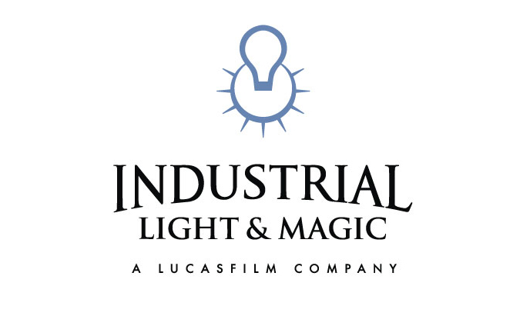
JOHN KNOLL
Visual Effects Supervisor

John Knoll joined Industrial Light & Magic as a technical assistant in 1986, and was soon promoted to motion control camera operator for “Captain EO.” After three years of operating, Knoll was called upon to work on the ground breaking digital effects for “The Abyss.” Since that time, he has been promoted to Visual Effects Supervisor helming the visual effects on more than twenty feature films and commercials. His film background coupled with an advanced understanding of digital technologies has made Knoll a much sought-after supervisor with three Academy Award nominations for “Star Wars: Episode II Attack of the Clones,” “Star Wars: Episode I The Phantom Menace,” which earned him a BAFTA nomination, and “Pirates of the Caribbean: The Curse of the Black Pearl,” in which he was also honored with a BAFTA nomination. Knoll’s resume also includes “Mission to Mars,” “Deep Blue Sea,” “Star Trek: First Contact” and “Mission: Impossible” among others. In 2005, he completed work on the final installment of the Star Wars series: “Episode III Revenge of the Sith.” In 2006 Knoll completed work on the sequel to the Pirates of the Caribbean films; Dead Man’s Chest for which he received both a BAFTA and an Academy Award®. More recently, Knoll was the ILM Visual Effects Supervisor on James Cameron’s science fiction epic Avatar and Gore Verbinski’s Rango, which was also ILM’s first foray into animated features.

Knoll’s interest in filmmaking began at an early age. Having a keen interest in visual effects, Knoll was mesmerized by the original “Star Wars.” During a visit to ILM in 1978 he was able to observe first-hand the world of visual effects. Inspired to learn more, Knoll attended the USC School of Cinema and earned a Bachelor of Arts in Cinema Production, while freelancing as a modelmaker at a variety of Los Angeles-based production facilities.

During his last year at USC, Knoll took an advanced animation class where he built a motion control system from an Oxberry animation stand, an Apple II computer, a CNC milling machine controller, and a bunch of industrial surplus stepper motors. Impressed by the student film that was generated from this class project, ILM hired Knoll as a technical assistant for motion control photography. Greatly impressed by visits to ILM's newly founded computer graphics department, Knoll took up computer graphics as a hobby. Teaming up with his brother who was working on his Doctoral Thesis in computer vision at the University of Michigan, the Knoll brothers created Photoshop in 1987.

(continues)

ILM CREDITS
Feature Films

2011 MISSION IMPOSSIBLE: GHOST PROTOCOL (currently in production) – Visual Effects Supervisor
2011 RANGO – Visual Effects Supervisor
2009 AVATAR – Visual Effects Supervisor
Visual Effects Society Award Nomination – Best Single Visual Effects of the Year
2008 CONFESSIONS OF A SHOPAHOLIC – Visual Effects Supervisor
2008 SPEED RACER – Visual Effects Supervisor/Lonely Highway Sequence
2007 NATIONAL TREASURE: BOOK OF SECRETS – Visual Effects Supervisor
2007 PIRATES OF THE CARIBBEAN: AT WORLD’S END – Visual Effects Supervisor
2006 PIRATES OF THE CARIBBEAN: DEAD MAN’S CHEST – Visual Effects Supervisor
Academy Award – Best Achievement in Visual Effects
British Academy Award – Best Achievement in Visual Effects
Visual Effects Society Award – Outstanding Visual Effects
Visual Effects Society Award – Best Single Visual Effects of the Year
2005 STAR WARS: EPISODE III “Revenge of the Sith” – Visual Effects Supervisor
Visual Effects Society Award Nomination – Best Visual Effects
Visual Effects Society Award Nomination – Best Single Visual Effect
2003 PIRATES OF THE CARIBBEAN – Visual Effects Supervisor
Academy Award Nomination – Best Achievement in Visual Effects

British Academy Award Nomination - Best Achievement in Visual Effects
Visual Effects Society Award Nomination – Best Visual Effects
2002 STAR WARS: EPISODE II “Attack of the Clones” - Visual Effects Supervisor
Academy Award Nomination - Best Achievement in Visual Effects
Visual Effects Society Award Nomination – Best Visual Effects
2000 MISSION TO MARS - Visual Effects Supervisor
1999 DEEP BLUE SEA - Visual Effects Supervisor
- STAR WARS: EPISODE I “The Phantom Menace” - Visual Effects Supervisor
Academy Award Nomination - Best Achievement in Visual Effects
British Academy Award Nomination - Best Achievement in Visual Effects
1996 STAR TREK: FIRST CONTACT - Visual Effects Supervisor
1996 STAR WARS SPECIAL EDITION - Visual Effects Supervisor
1996 MISSION: IMPOSSIBLE - Visual Effects Supervisor
1994 STAR TREK GENERATIONS - Visual Effects Supervisor
1994 BABY'S DAY OUT - Visual Effects Supervisor
1992 PHOENIX WATER PARK (Simulator Ride) - Director
1991 HUDSON HAWK - Visual Effects Supervisor
1991 HOOK - Associate Visual Effects Supervisor
1990 THE HUNT FOR RED OCTOBER - Associate Visual Effects Supervisor
1989 THE ABYSS - Computer Graphics Project Designer
1988 WILLOW - Motion Control Camera Operator
1987 INNERSPACE - Motion Control Camera Operator
1987 EMPIRE OF THE SUN - Motion Control Camera Operator
1987 STAR TREK: THE NEXT GENERATION - Motion Control Camera Operator
1987 STAR TOURS (Simulator Ride for Disneyland) - Motion Control Camera Operator
1986 STAR TREK IV: THE VOYAGE HOME - Motion Control Camera Operator
1986 CAPTAIN EO - Motion Control Camera Operator

(continues)

Commercials

1991 INTEL "Computer Inside" - Director
1991 DODGE DAYTONA "Starting Price" - Visual Effects Supervisor
1990 PANASONIC "Broadcast Simulator" - Visual Effects Supervisor
1990 NEC "Turbo Grafix" - Visual Effects Supervisor
1990 CHEVRON "High Performance" - Visual Effects Supervisor
1990 CRYSTAL LIGHT "Shade" - Visual Effects Supervisor
1989 FDA "Radon" (PSA) - Visual Effects Supervisor
1989 US AIR "Ballet" - Director
1988 PACIFIC BELL "Smart Yellow Pages" - Visual Effects Supervisor
1987 LUCASFILM LTD "THX” (Trailer) - Motion Control Camera Operator
3/11

